The Effects of Lavender and Peppermint Essential Oils on Anxiety-Like Behaviors in Rodents

Jenna Beakas

Natural Sciences Department, Malone University Advisor: Lauren Seifert, Ph.D.
December 6, 2021

Abstract

Lavender essential oil has been used as a treatment for anxiety in humans, while peppermint essential oil has been known to increase concentration in humans. There have been published studies showing a correlation between lavender essential oil inhalation and decreased anxiety-like behaviors in rats. However, no such research has been published on the effects of peppermint essential oil on anxiety-like behaviors in rats. This study examines the effect of both peppermint and lavender essential oils on anxiety-like behaviors in rats by using time spent in the closed versus open arms of the elevated plus maze as a measure of anxiety-like behaviors. Sixteen adult male Long-Evans (outbred) rats were tested in an elevated plus maze (EPM) on three occasions (Baseline 1, Intervention, Baseline 2). In this mixed design study, there were both
between-subjects (grouping in peppermint or lavender) and within-subjects (three EPM tests) variables. Results revealed no group difference. However, there was a significant difference with regard to the within-subjects variable. Baselines 1 and 2 yielded similar scores; whereas the Intervention difference score indicated more time spent in the open arms across both groups.
Implications of these findings are that both peppermint and lavender may have had anxiolytic effects.

The Effects of Lavender and Peppermint Essential Oils on Anxiety-Like Behaviors in Rodents
*Submitted in partial fulfillment of the requirements for graduation from the Malone University Honors Program.

Anxiety in Humans
Anxiety, as an emotion, consists of feelings of tension, worried thoughts and physical changes, such as increased blood pressure, sweating and breathing rapidly (American Psychological Association [APA], n.d.). While occasionally feeling anxiety as an emotion is normal, anxiety disorders are the most common psychiatric disorders with a worldwide prevalence of 3.6%, although this number is likely an underestimation of the true percentage due to cases being underreported (APA, n.d.; Lizarraga‐Valderrama, 2020). In total, 264 million people reported suffering from anxiety disorders, and, according to the World Health Organization, anxiety is the sixth largest contributor to global disability (Lizarraga‐Valderrama, 2020). These disorders are characterized by frequent, intense, excessive and persistent worry, fear and ruminating thoughts about everyday situations (APA, n.d.). Anxiety disorders include generalized anxiety disorder, social anxiety disorder, specific phobias, separation anxiety disorder, substance-induced anxiety disorder and panic disorder with or without agoraphobia (Malcolm & Tallian, 2018). Generalized anxiety disorder, specifically, is characterized by persistent and excessive anxiety and worry about activities or events that is hard to control, out of proportion to the actual circumstance, and negatively alters how the person affected feels physically (Malcolm & Tallian, 2018). The most common treatments for these anxiety disorders incorporate both pharmacotherapy and psychotherapy (Lizarraga‐Valderrama, 2020).

Anxiety in Rodents

The following information regarding anxiety in rodents was adapted from Lezak et al. (2017). Research on psychiatric disorders and illness can be challenging to conduct in rodents, as many of the signs and symptoms of these disorders in humans are not observable in rats and mice. These signs and symptoms include motivations, emotions, and thought processes that cannot be directly assessed in non-human species. However, behavior can still be assessed in rodents as indicative of various psychiatric illnesses in humans, such as anxiety disorders. It is important to note that these anxiety-like behaviors in rodents are called such since they mirror anxious behavior in humans. These behaviors are interpreted as anxiety-like, but we take care not to assume that the animal has anxiety because the subject cannot report to us about its affect.
Anxiety-like activities in rodents can be characterized by increased vigilance, freezing and/or hypoactivity, elevated heart rate, and suppressed food consumption. Additionally, rodents naturally prefer dark and enclosed environments that protect them from predators, as opposed to light and open environments. One model of anxiety in rats involves the elevated plus maze (EPM); generally, animals spend more time in the dark and enclosed areas compared to the illuminated and open areas (Walf & Frye, 2007). Presumably, greater amounts of time spent in the closed arms of the EPM indicate higher anxiety levels, while more time spent in the open arms indicates lower anxiety levels. Rats perceived as having higher anxiety levels are those who are quicker to leave the open arms (Walf & Frye, 2007).

Mechanistic Action of Essential Oils on the Central Nervous System

The pharmacology of essential oils has been experimentally researched to determine the neural pathways involved in their modes of action, which has allowed for insight into both their physiological and psychological effects (Lizarraga‐Valderrama, 2020). The use of animal models has shown the neuropharmacological effects of essential oils on the

hypothalamic-pituitary-adrenal (HPA) axis, the sympathetic nervous system and in serotonergic, dopaminergic and GABAergic neurotransmitter systems (Lizarraga‐Valderrama, 2020). For lavender essential oil specifically, pioneer studies seem to point at the GABAergic system as the source of lavender essential oil’s anxiolytic and antidepressant properties (Lizarraga‐Valderrama, 2020). This is due to linalool, one of the major components of lavender essential oil, acting postsynaptically by potentially altering the activity of cyclic adenosine monophosphate (cAMP) (Stea et al., 2014). As a result, linalool has been shown to inhibit GABA(A) binding receptor within the central nervous system (CNS) in animal models to generate a relaxed state (Stea et al.,
2014). However, this inhibition has not been shown in human studies (Stea et al., 2014). Differing from the proposed mechanisms for lavender essential oil, the molecular pathways involved in peppermint essential oil’s anxiolytic properties are unknown (Lizarraga‐Valderrama, 2020).
As a result of the interaction of essential oils with this array of central nervous system
receptors, physiological changes are measurable that in turn allow for measurable psychological effects (Lizarraga‐Valderrama, 2020). For example, some of these physiological changes shown in clinical trials as a response to inhalation of essential oils include changes in heart rate, blood pressure, respiratory rate, cortisol serum levels and brain wave composition (Lizarraga‐Valderrama, 2020). Feelings of relaxation, contentment, and alertness were also shown (Lizarraga‐Valderrama, 2020). In order to gain further insight into the physiological and psychological effects of essential oils needed for the development of essential oil-based drugs, more clinical research must be conducted to assess the synergetic effects of essential oils as well as the complex receptor-essential oil compound interaction (Lizarraga‐Valderrama, 2020).

Aromatherapy: Lavender and Peppermint Essential Oils

Currently, selective serotonin reuptake inhibitors and selective serotonin norepinephrine reuptake inhibitors are two of commonly-used antidepressants, and benzodiazepines (BDZs) are the most commonly used anxiolytic prescribed to treat anxiety disorders (Lizarraga‐Valderrama, 2020). Unfortunately, these treatments bring along various negative side effects that cause a suboptimal therapeutic outcome in some patients (Lizarraga‐Valderrama, 2020). Chronic use of benzodiazepines, for example, cause lethargy, drowsiness, dizziness, vertigo, tolerance, and sedation (Lizarraga‐Valderrama, 2020). Even more concerning, older adults taking BDZs have reported an increased number of falls and exacerbation of cognitive decline (Lizarraga‐Valderrama, 2020).
In an effort to find safe treatment options for anxiety disorders that do not have
dependence, withdrawal, or abuse potential, as well as to avoid the side effects associated with chronic use of synthetic anxiolytic drugs, aromatherapy has been a suggested alternative (Lizarraga‐Valderrama, 2020; Malcolm & Tallian, 2018). Aromatherapy is the use of essential oil inhalation for therapeutic benefit, and an essential oil is a concentrated hydrophobic liquid containing volatile chemical compounds extracted from plants (John Hopkins Medicine, n.d.).
Supposedly, only some of the major compounds of the essential oils, such as linalool, limonene, and pinene, provide significant anxiolytic effects (Lizarraga‐Valderrama, 2020). For this reason, it is expected that essential oils that contain high levels of these compounds should provide an anxiolytic effect (Lizarraga‐Valderrama, 2020).
Specifically, lavender essential oil (Lavandula angustifolia), which contains linalool, has

a history of providing an anxiolytic benefit that has been supported by clinical efficacy studies (Malcolm & Tallian, 2018). In addition to lavender essential oil, peppermint essential oil (Mentha piperita) has also been suggested to have anxiety-reducing potential. According to Akbari et al.

(2019), inhalation of peppermint prior to intravenous catheterization lessened the pain and anxiety caused by the procedure in cardiac patients. Alternatively, peppermint has been suggested to reduce stress as well as improve mental function and attention orientation (National Center for Complementary and Integrative Health [NCCIH], n.d.). According to anecdotal evidence and correlational-based clinical studies, peppermint has been suggested as a possible therapeutic tool to help those with attention-deficit/hyperactivity disorder (ADHD) sustain attention (Göbel et al., 1994). ADHD is a neurodevelopmental disorder characterized by one or all of the following: trouble in paying attention, difficulty in controlling impulsive behaviors, and hyperactivity (Centers for Disease Control and Prevention [CDC], 2020). Treatment for ADHD usually consists of cognitive behavior therapy (CBT) and/or medications, which can be stimulants or nonstimulants (CDC, 2020). Unfortunately, these medications can be accompanied by unwanted side effects, such as decreased appetite and sleep problems (CDC, 2020). With this being said, peppermint is of specific interest to those suffering from the negative side effects of their ADHD medication, as well as those without ADHD to help orient attention, improve mental function and lower stress levels (Göbel et al., 1994).
As shown, studies have primarily focused on the use of peppermint essential oil as an attention-orienting agent in humans (Göbel et al., 1994). The current study did not test peppermint’s effect on attention. Instead, I investigated peppermint’s effect as a comparative agent relative to lavender and with respect to anxiety-like behaviors in rodents (Rattus norvegicus). To examine the potential effects of lavender and peppermint inhalation as therapeutic substances to alleviate the symptoms of human anxiety disorders, rodents can be first used, as their behaviors can be indicative of anxiety (Chioca et al., 2013). Rodents provide a useful model for testing anxiolytic agents (Chioca et al.. 2013). And it is important to note that the chemical

components of essential oils produce their effect synergistically; therefore; the experimentation for the purposes of this study was conducted using the entire essential oil as opposed to their isolated individual components (Lizarraga‐Valderrama, 2020).

The Current Study

Given the foregoing, a question is whether there are different essential oils that might reduce anxiety in rodents in comparison to lavender. Because peppermint increases focus in humans, it would be logical to conjecture that it might have similar effects in rats. However, there is general lore to indicate otherwise (Orkin, n.d.). So, I proposed to compare lavender and peppermint oil inhalation across two randomly assigned groups of rats and predicted that lavender would be anxiolytic in comparison to peppermint. My measure of anxiety was the relative amount of time a rat spends in closed arms versus open arms of an elevated plus maze.

Methods

Animals and Housing

Sixteen adult male Long-Evans (outbred) rats (range: 65.5 g – 87 g, average: 76.25 g) were received at postnatal day 27/28 and tested from postnatal day 65/66 to 107/108. Rats were at P65 or P66 days for Baseline 1, P86 or P87 for Intervention, and P107 or P108 for Baseline 2. At the final test (Baseline 2) the rats’ mean weight was 223.50 g (9.89 g standard deviation, 212.5 - 245 g range). Rats were tested and housed individually in polypropylene cages (47.63 cm X 27.3 cm X 21.59 cm) with hypoallergenic sustainably produced paper bedding. The Long-Evans rat was chosen due to its accessibility, affordability and its reputation as a common model in behavioral and psychological research.
Sixteen Long-Evans rats were randomly assigned to 2 equal groups: a Lavender Group and a Peppermint Group. All animals were their own controls, using an A-B-A within-subjects

test of Baseline-Treatment-Baseline. Between-groups tests involved comparisons of the two groups at each stage of testing: initial baseline, treatment, and return-to-baseline.
All animals were housed under controlled lighting on a 12/12 cycle (12 hours dark; 12 hours light). Ambient temperature of the animal housing room was maintained between 18.33 and
23.89 degrees Celsius. Water was given ad libitum; food was provided once daily (after testing) in order to help motivate maze exploration behaviors. Subjects were acclimated to the testing environment and the experimenter throughout their juvenile interval (27/28 through 60
days-of-age) before the behavioral tests begin (Stanford, n.d.).

Materials and Procedures

*A full equipment list can be found in the Appendix (page 27).

Essential Oils

*The following information regarding Lavender and Peppermint essential oils was obtained from Lizarraga‐Valderrama (2020).
- Lavender (Lavandula angustifolia)

Using steam distillation, Lavender essential oil is extracted from the flowers of the evergreen shrug Lavandula angustifolia Mill and consists of the following major compounds: linalyl acetate, linalool, lavandulyl acetate, myrcene, terpinen-4-ol, -terpineol, cis-linalool oxide, trans-linalool oxide and ocimene. I used 100% pure lavender essential oil (Lavandula angustifolia) containing linalool and linalyl acetate.
- Peppermint (Mentha piperita)

Using steam distillation, peppermint essential oil is extracted from the leaves of

Mentha piperita. Peppermint essential oil is made up of more than 26 compounds, with

the majority being oxygenated monoterpenes (mainly menthol and iso-menthone). I used 100% pure peppermint essential oil (Mentha piperita) containing menthol and menthone.

Elevated Plus Maze (EPM) Equipment

- Apparatus: maze in a plus-shape with two closed and two open arms (see “Construction of the Elevated Plus Maze” below for instructions to build this apparatus and the Appendix for materials needed to build the maze)
- Camera: must have an overhead view of the maze. This provides video of the maze in order for checking of latency measures related to animal movement at the + portion (center) of the maze as well as the closed and open arms.
- Two privacy blinds surrounding EPM to eliminate external room cues

- Two standing lamps with three white light bulbs to be positioned facing the two open arms next to privacy blinds and pointed toward the EPM
- Oxivir™ disinfectant to be utilized between trials in an effort to eliminate visual and olfactory residue in EPM
*The materials list above for the EPM was obtained from Stanford Behavioral and Functional Neuroscience Laboratory’s “Elevated Plus Maze Standard Operating Procedure” (Stanford, n.d.). Oxivir™ was used in place of Virkon disinfectant.

EPM Description

The elevated plus maze (EPM) was a behavioral assay conducted to test the presence and fluctuation of anxiety-like behaviors in rodents (Lezak et al., 2017). The EPM was utilized in this study as a method for comparison of anxiety-like behaviors before and after the inhalation of lavender and peppermint essential oils (Lezak et al., 2017). Structurally, the EPM was a plus sign shaped structure elevated fifty centimeters above the ground made up of two opposed enclosed

arms with walls on the sides, two opposing nonenclosed (open) arms, and an open roof that enabled video recording from above (Lezak et al., 2017). While the EPM induced anxiety in rodents that were exposed to the open arms, it also tested anxiety levels in rodents by measuring latency to enter, time spent within both in the open arms versus the closed arms as well as number of entries into the open and closed arms (Lezak et al., 2017). Latency to enter, time spent within, and number of entries into both the closed and open arms were methods of measuring anxiety levels (Lezak et al., 2017). As was mentioned, greater amounts of time spent in the open arms was indicative of lower anxiety levels (and more exploration), while less time spent in the open arms was interpreted as higher anxiety levels, as avoidance of the open arms was a proxy for anxiety (Lezak et al., 2017). In this way, the EPM intertwined rodents’ preferences for dark spaces and avoidance of illuminated and open areas (Lezak et al., 2017).

Construction of the EPM*

The elevated plus maze was constructed at home, rather than by a manufacturing company, in an effort to lower expenses. The materials needed are listed above under the “Elevated Plus Maze (EPM) Equipment” subheading and in the Appendix (p. 27). The EPM had a small platform in the center with four surrounding arms that were all 90 degrees from each other. These arms were 50 cm in length and 10 cm in width (“Elevated Plus Maze,” 2020). Opposing arms matched each other, meaning that the open arms were opposite each other and the enclosed arms were opposite each other (“Elevated Plus Maze,” 2020). The enclosed arms had approximately 40 high walls (“Elevated Plus Maze,” 2020). The roofs were open for all of the arms, while the walls were opaque (“Elevated Plus Maze,” 2020). The flooring and walls were made of plywood, and the legs were 2 x 4s, all of which was purchased at Home Depot. I made sure that the floor did not blend in with the color of the rats being tested to ensure that the test

subjects were easily observable when in the maze (“Elevated Plus Maze,” 2020). The floor was lined with a plastic sheeting to allow for ease when cleaning to get rid of the scent from previous trials. The entire EPM apparatus was raised to 50 cm above the ground (“Elevated Plus Maze,” 2020). Furthermore, the lighting illumination was consistent throughout the EPM so that the EPM was well lit to avoid shadows in the maze (“Elevated Plus Maze,” 2020). The EPM was cleaned both before and after each trial in order to avoid any residual odors from previous experimentation (“Elevated Plus Maze,” 2020).

Figure 1

Standard Elevated Plus Maze Apparatus
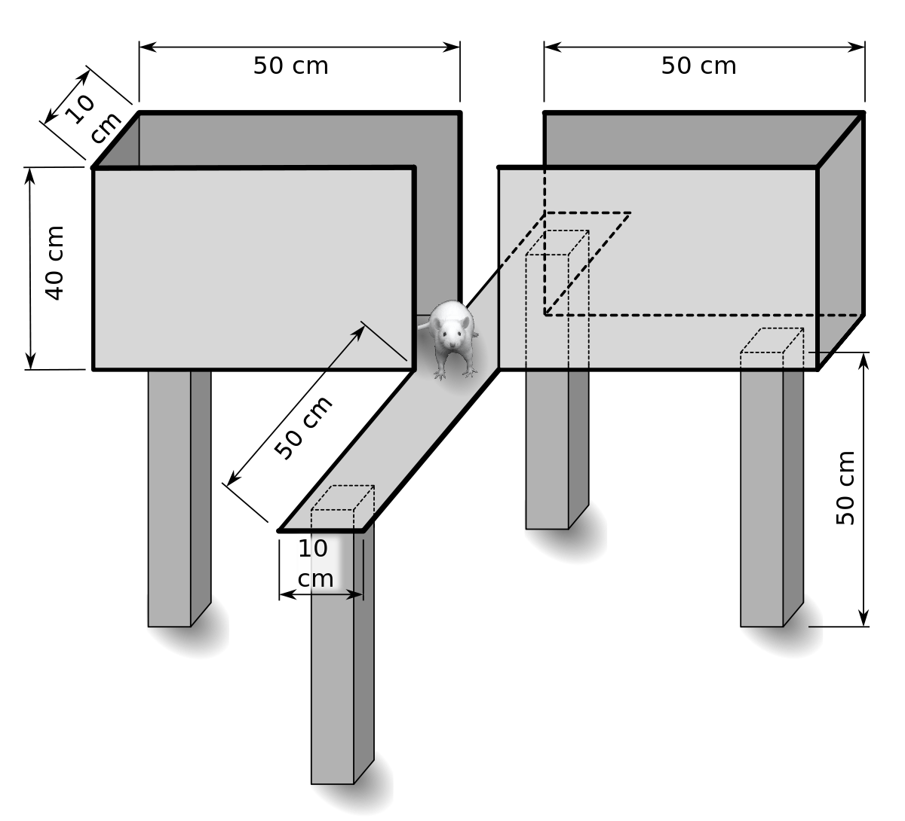

Note. Walls surround the closed arms. In this figure, the rat is in the center, between the closed and open arms. The elevation of the EPM is 50 cm.

Figure 2

Home-Constructed Elevated Plus Maze Apparatus

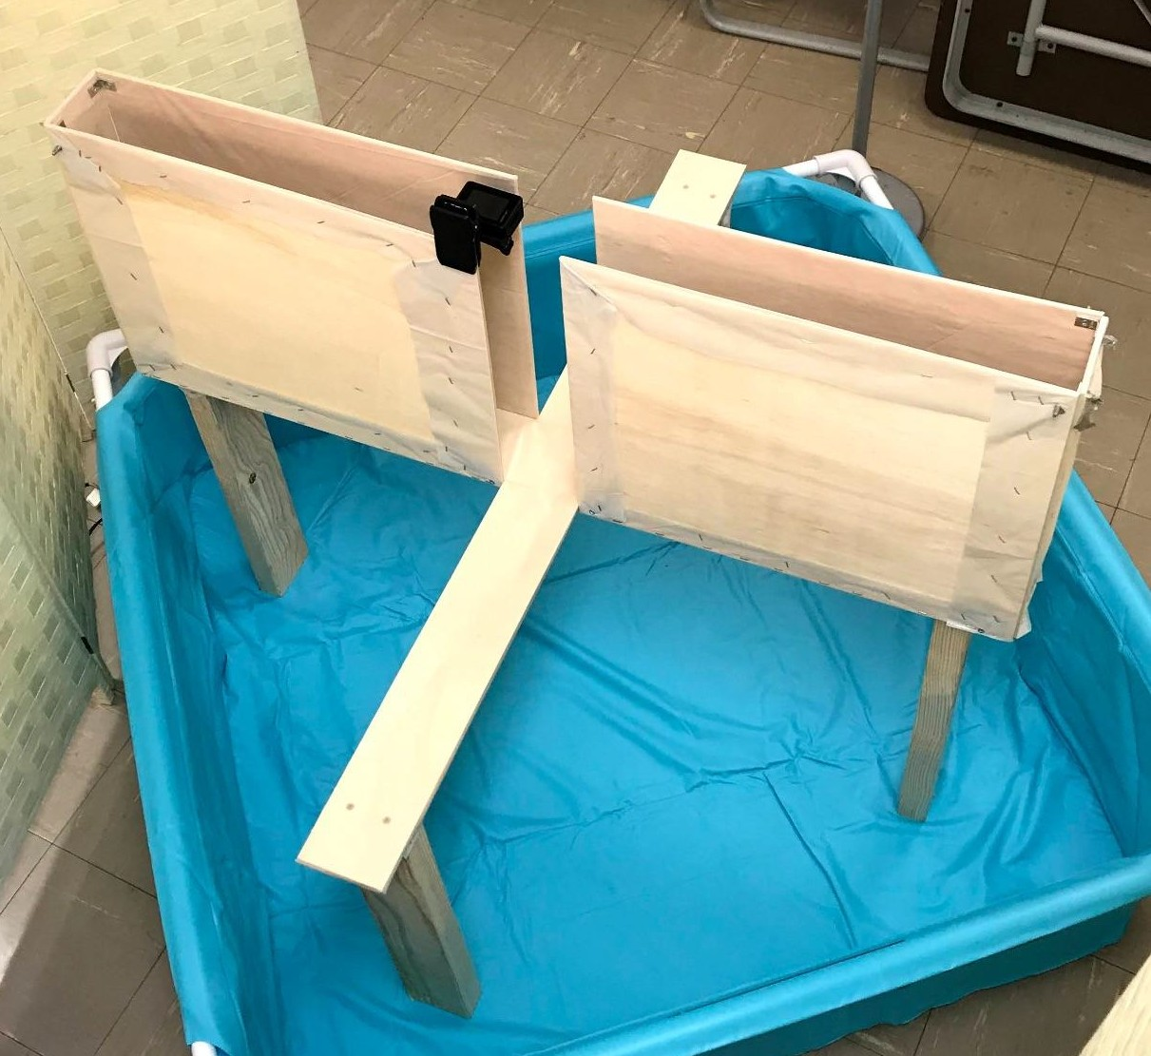

Note. All measurements are the same as in Figure 1.

The design for this study was a mixed design with one (3 conditions) within-subjects factor (Baseline 1-Scent Condition-Baseline 2) and one (2 conditions) between-subjects factor (Group 1: Lavender versus Group 2: Peppermint). Sixteen Long-Evans male outbred rats were tested, with eight randomly assigned to each group.

Habituation to Handling and the Scent Chamber

Animals arrived in the animal housing room on 23 Aug 2021, at 27-28 days-of-age and were handled and exposed to a neutral chamber (used later as the scent exposure chamber).
Animals were handled every other day during the juvenile-to-adulthood interval and exposed to the neutral scent-exposure chamber at the same interval. These events were designed to habituate the animals to human handling and to the chamber where they were exposed to essential oil (lavender or peppermint). Two identical scent-exposure chambers were used: one for Group 1 (lavender) and another for Group 2 (peppermint).

Baseline Testing

Animals were tested in the EPM in random order on testing days (September 30: Baseline 1; October 21: Scent Condition; November 11: Baseline 2). Three weeks were ensued between

tests in keeping with Walf and Frye’s (2007) recommendation that rodents should not be exposed to an elevated plus maze on multiple occasions unless a 21-day period occurred between exposures, as a less than 21-day period between exposures could have caused test decay effects. Test decay effects occur when there are rising differences in elevated plus maze behavior when rodents are exposed to the EPM more than once within a 21-day period (Walf & Frye, 2007). An example of a test decay effect is decreased activity on the open arms of the EPM upon second exposure compared to first exposure (Walf & Frye, 2007). Rather than decreased activity on the open arms of the EPM solely due to anxiety induction, the second exposure is a confounding variable (Walf & Frye, 2007). With this knowledge, to avoid a drop in baseline open arm exploration due to second exposure to the maze within a 21-day period, testing occurred 21 days apart (Walf & Frye, 2007). This allowed for measurement of the unconditioned avoidance response towards the open arms without the effects of previous exposure (Walf & Frye, 2007). A second baseline test (Baseline 2) for each animal occurred on November 11 in order to provide a reliability check for Baseline 1.

Essential Oil Administration and Inhalation

Protocols for essential oil administration followed those of Chioca et al. (2013). Distilled water served as a control. The distilled water and essential oils were stored in a polyethylene bottle and amber glass bottles, respectively, until administered. As for the inhalation procedure, each rat was moved to the scent exposure chamber. Then, cotton (0.5 grams) was positioned in a small plastic container and soaked with distilled water, lavender essential oil, or peppermint essential oil at a fixed volume of 1 mL. Once the cotton ball was soaked, I placed the plastic container with the cotton ball in the corner of the scent chamber. The polyethylene bottle (for the distilled water) or the glass bottles (for the lavender and peppermint essential oils) were closed

shut. The rats inhaled the distilled water, lavender, or peppermint essential oil for 3 minutes, followed by immediate testing. After each test, the used cotton ball was discarded, and a new cotton ball was used for the next animal’s test. Exposure to scent in the scent-exposure chamber happened only once, on October 21, 2021, and each animal was tested in the elevated plus maze immediately after its scent exposure.

Testing Conditions for the EPM

*Recommendations about timing of testing and handling of animals before testing were adapted from Walf and Frye (2007).

Timing of Testing

Circadian rhythms/light cycle could have influenced rats’ behaviors in the elevated plus maze. The rats were housed on a reverse-light cycle with testing always conducted during their dark phase in order to avoid inconsistencies in what phase of the light cycle animals are tested. During their dark phase, rats were most active and had consistent differences in endogenous hormone concentrations, specifically corticosterone, estrogens, progestins, and androgens.
Therefore, consistent testing strictly in the animals’ dark phase reduced potential for the timing of testing as a confounding variable during the behavioral analyses using the EPM.

Handling of Animals before Testing

It was important that no animal had prior handling or stress from injections on the days of testing, as these could have changed the animals’ behaviors in the elevated plus maze. For this reason, efforts were made to eliminate inconsistencies relating to the handling of animals and prior stressors immediately before testing using the elevated plus maze. These efforts involved animals being consistently habituated to being handled by experimenters, consistency in housing and location of the elevated plus apparatus in the laboratory as well as consistent transportation

procedure from the home cage to the elevated plus maze apparatus and return to the home cage at the end of testing. The housing and behavioral testing sites were in adjacent rooms, so I carried each home cage individually into the testing room during the rat’s test, followed by returning the cage to the housing room. Therefore, transportation of the animals only took place from the home cage to the scent chamber to the elevated plus maze apparatus. Every effort was made to remove stress before testing and maintain consistent experiences across animals.

Elevated Plus Maze Testing

Part 1: Distilled Water/Essential Oil Exposure

- Selected the rat for testing from the randomized order (below). For baseline measures, no experimental condition was present. However, each rat’s condition, as determined by a random number generator, was noted in the data collection spreadsheet. The order of testing was the same for Baseline 1, Intervention, and Baseline 2. [Order of testing: 1 = I, 2 = C, 3 = K, 4 = G, 5 = P, 6 = A, 7 = H, 8 = D, 9 = J, 10 = O, 11 = M, 12 = F, 13 = L, 14 = E, 15 = N, 16 = B]
- Removed the rat from its individual home cage and placed the rat in the scent chamber with a container that held the cotton ball doused with distilled water (1 mL using a syringe) for Baselines 1 and 2 and lavender or peppermint essential oil for Intervention. The cotton balls were per animal just before the animal was put into the scent chamber. This was because if all the cotton balls were prepared ahead of time, the water or scent would have evaporated, so each animal would not have been exposed to the same amount of scent. I timed the exposure to the cotton ball [3 minutes]. All animals approached the cotton ball during their 3 minutes in the scent chamber.
Part 2: Elevated Plus Maze Testing

- Cleaned (with Oxivir™ disinfectant) and dried the elevated plus maze prior to testing.

- Started the video device. I started the video recording before I placed the rat in the EPM so that no behaviors were missed.
- Showed the index card for the rat being tested in the camera view before taking the rat from the scent chamber to the EPM. This was so that the rat’s number, letter, and condition were recorded.
- Removed the rat from the scent chamber and placed the rat at the junction of the open and closed arms with the head of the rat facing the open arms opposite to where I was standing. My handling and placement position of the animal into the EPM was consistent for each test subject. I avoided placing rats towards the closed arm, and ensured that each rat was placed on the EPM facing the same open arm.
- Started the 5 minute timer simultaneously with placement of the rat on the EPM. I eliminated unnecessary movement and noise production.
- Removed rat from EPM at the end of 5 minute test and returned rat to its home cage.

- Cleaned the EPM with Oxivir™ disinfectant and dried with paper towels between test subjects.
- Prepared the data collection sheet. The spreadsheet included the subject number of the animal, date, and coded condition. Following recording of all EPM tests, data was collected from the videos and recorded in the data collection sheet. The information and behaviors recorded are listed below.
  - Time spent in closed arm

  - Time spent in open arm

    - Closed arm time - open arm time indicated relatively more anxiety when a positive score and less when a negative score.
  - Open arm entries made

  - Closed arm entries made

    - Open and closed arm entries were only counted when all four paws of the rat were on the open or closed arm, respectively.
  - Total entries made

  - Head dips: downward movement of rodent’s head towards the floor in the open arm
  - Rears: vertical standing of rodent on two hindlegs

    - Supported rearing: rat reared against walls of the EPM (Sturman et al., 2018)
    - Unsupported rearing: rat reared without contacting walls of the EPM (Sturman et al., 2018)
  - Stretch-attend posture: body of rodent was stretched forward/toward a stimulus but rodent is motionless; neuraxis was parallel to the floor (rat is on all fours); stretching the head and shoulders forward and subsequently retracting to the original position (Sestakova et al., 2013)
  - Grooming: rodent licked and rubbed its paws on its body (Rousseau et al., 2000)

*The procedure above was adapted from (Walf & Frye, 2007). It has been slightly modified to fit the current study’s objective.

Timing

- Steps 1 and 2: cotton ball preparation and inhalation

  - Each animal was put in the scent chamber for 3 minutes just before it was put into the EPM.
  - 3 minutes per rat x 16 rats = 48 minutes total distilled water or essential oil inhalation
- Steps 3 and 9: EPM cleaning

  - 3 minutes per rat x 16 rats = 48 minutes total spent preparing (cleaning) the EPM prior to use and between each test
- Steps 4 - 8: EPM testing

  - 5 minutes in the EPM per animal → 80 minutes for 16 animals

- Step 10: data collection

  - I watched each rat’s 5 minute test video multiple times in order to collect the different information. This process took about 5 to 7 hours total.
Summary of Timing:

- Cleaning EPM (steps 3 and 9) = 3 min per rat x 16 rats = 48 minutes

- 3 minutes scent exposure + 5 minutes in the EPM = 8 minutes per rat

  - 8 minutes per rat x 16 rats = 128 minutes (2 hours, 8 minutes) total testing time time
- 128 minutes testing time + 48 minutes cleaning = 176 minutes = 2 hours, 54 minutes needed total for testing days

Responses to Unexpected Circumstances During Testing

Rodents fell off open arms. Rats ran to the edge of the open arms and fell off infrequently (only rat E fell off twice; Walf & Frye, 2007). In keeping with Walf and Frye’s (2007) recommendations, under this circumstance, the animal was rapidly picked up by the experimenter and placed back

onto the open arms of the maze. I recorded this fall on the data sheet, but I did not exclude behavioral data from this animal from analysis. The 5 minute test was continued with the animal who fell off the open arm in order to ensure that exposure to the EPM was as consistent across animals as possible.
Rodents were immobile/motionless on open arms. Walf and Frye (2007) provided recommendations as to what to do if rats were immobile or motionless on the open arms. However, in my experiments, rats were never motionless on the open arms for an extended period of time in response to noise or movement during testing. If this were to happen, it may have led to the rat spending the majority of the testing time motionless on the open arms of the maze. If the rat spent more than 30% (100 seconds) of the total testing time on the open arm, this rat was considered to be motionless for an extended period on the open arms. In Walf & Frye’s (2007) experiments, this immobility of the rats on the open arms only occurred in less than 1% of the animals that were tested.
In the rare occasion that immobility did occur, but not in response to loud noise or movement, this action should have also been recorded on the data sheet as a deviation from standard behavior and taken into consideration when performing analysis of behavioral results. Alternatively, if immobility occurred as a result of a loud noise or movement, these animals’ data was to be excluded and not included in behavioral analysis. Although the data would have been discarded, I would have needed to continue the 5 minute EPM test to keep consistent with the other animals. I reduced potential for immobility of the rats on the open arms by avoiding noise and movements. While testing, a sign was placed outside of the testing room and vivarium to make others outside the testing room aware of the importance of remaining as quiet as possible during testing periods.

Different baseline/open arm activity. It was important to factor in the sex and reproductive age of test subjects for behavioral testing. This was because differing baseline elevated plus maze behavioral patterns have been reported by Walf & Frye (2007) depending on sex of experimental animals, age and stage in the estrous cycle (for females). In order to avoid having the estrous cycle as a potential confounding variable when observing elevated plus maze behavior, all male Long-Evans rats were chosen as test subjects. They were 27 or 28 days of age upon arrival in the laboratory. The age was decided on so that the rats were juveniles and to ensure that they were accustomed to the animal handlers before testing began at 60/61 days of age (adulthood).

Data Analyses

The experimental manipulations were the inhalations of either distilled water (Baselines 1 and 2) and lavender or peppermint essential oils (grouping variable for the Intervention). In order to determine the effects of the essential oil inhalation on anxiety-like behaviors in rats, I used analysis of variance (ANOVA) for the mixed design. ANOVA was used to determine whether difference scores (time spent in closed - time spent in open arms) were different between groups or across the three times of test (Baseline 1, Scent Intervention, Baseline 2). While raw data were collected regarding additional behaviors (as mentioned above, e.g., entries into closed arms, entries into open arms, rearing, stretch attend postures, etc.), they were not analyzed owing to lack of time and because the primary hypothesis was linked to time spent in closed and open arms.
Following the two-way ANOVA, which tested differences between groups and within subjects, three paired t-tests were performed to determine whether Baseline and Intervention conditions were significantly different from each other.

Results

ANOVA for the mixed design yielded no significant effect of the grouping (lavender versus peppermint) variable, F(1, 14) = 0.002, p = 0.96. However, there was a significant effect of the within-subjects variable (Baseline 1 - Scent Intervention - Baseline 2), F(2, 28) = 8.65, p <
.01. [The interaction effect was not significant.]

In order to further investigate the significant within-subjects effect, I conducted paired t-tests (post-hoc comparisons). Three paired t-tests were run: Baseline 1 versus Baseline 2,
Baseline 1 versus Intervention, and Baseline 2 versus Intervention. The first paired samples t-test post-hoc revealed that rats spent significantly more time in the closed arms during Baseline 1 (N = 16, M = 194, SD = 91.71) than they did during Intervention (N = 16, M = 88.38, SD = 132.64); t(1) = -3.57, p = .0028. The second paired t-test revealed that rats spent significantly more time in the closed arms during Baseline 2 (N = 16, M = 185.5, SD = 103.12) than they did during Intervention; t(1) = 3.86, p = .0015. However, time spent in the closed arms during Baseline 1 and Baseline 2 were not significantly different from each other; t(1) = -.31, p = .76.
This research failed to reject the null hypothesis that there was no influence of type of essential oil (peppermint or lavender) on time spent in the closed arms of the elevated plus maze. On the other hand, there was an effect of inhaling an essential oil, regardless of whether it was peppermint or lavender, on time spent in the closed arms of the EPM. A caution was that the sample size was small (i.e., 8 animals per group). Thus, the power may have been exceeded during post-hoc comparisons.

Figure 3

Baseline 1 Difference Score vs. Animal

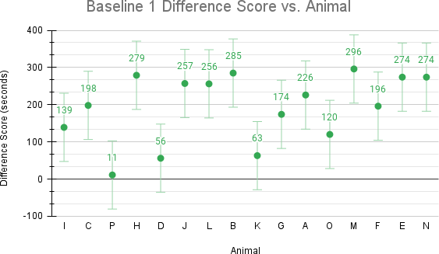

Note. Difference score was defined as time in the close arms - time in the open arms in seconds. Difference scores between Baseline 1 and Baseline 2 (Figure 4) were not significantly different.

Figure 4

Baseline 2 Difference Score vs. Animal

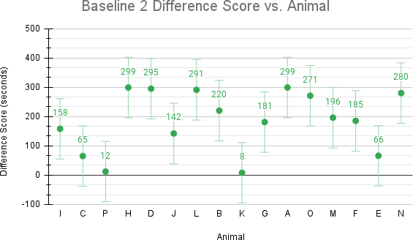

Figure 5

Intervention Difference Score vs. Animal

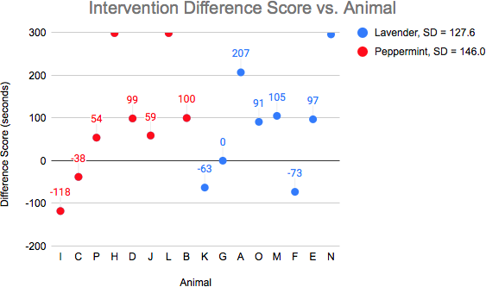

Note. The difference scores for the peppermint group were not significantly different from the difference scores in the lavender group, resulting in no grouping difference.

Figure 6

Average Difference Scores vs. Animal

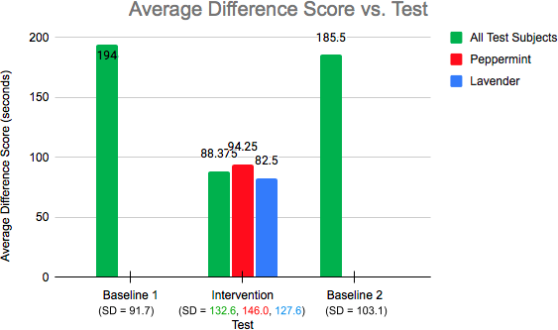

Note. Independent of grouping, the average difference score for Intervention was significantly lower than for Baseline 1 and Baseline 2. The average difference scores for Baseline 1 and Baseline 2 were not significantly different.

Discussion

As shown by the ANOVA and paired t-tests, there was no significant difference between groups, indicating no difference in the effect of lavender compared to peppermint. While results did not differentiate between the effects of peppermint versus lavender essential oils, results did show that both of these essential oils did have anxiolytic effects, as the Intervention times were significantly different than Baseline times. Inhaling something prior to testing lowered
anxiety-like behaviors in the EPM as measured by time spent in the closed arms - time spent in open arms.
While I predicted, based on published research findings, that lavender would have an anxiety-reducing effect, I was uncertain as to whether peppermint would produce the same effect in rats. As mentioned, in humans, peppermint has been shown to improve concentration, but no such data has been found for rats. The present study does not evaluate different concentration levels of lavender or peppermint inhalation; however, it does show that perhaps peppermint essential oil has anxiety-reducing effects (as does lavender) in rodents.
According to the Anxiety and Depression Association of America [ADAA], “anxiety disorders are the most common mental illness in the U.S., affecting 40 million adults in the United States age 18 or older, or 18.1% of the population every year.” (“Facts & Statistics,” n.d.). Although treatments for anxiety disorders are being researched extensively and there already exists variable attainable treatments for these disorders, only 36.9% of people diagnosed are treated (ADAA, n.d.). Furthermore, doctor visits are three to five times more likely, and hospitalization rates for psychiatric disorders are six times more likely for people diagnosed with an anxiety disorder than people who are not (ADAA, n.d.). Along with anxiety disorders, the ADAA also reports on ADHD, which is another psychiatric disorder that impacts “about 4% of

the adult population, or 8 million adults” (“Adult ADHD,” n.d.). About 50% of these 8 million adults with ADHD are also diagnosed with an anxiety disorder.
The comorbidity between anxiety disorders and ADHD and large portion of adults affects exemplifies the need for effective and affordable treatment options for these psychiatric disorders. While the current study’s finding about peppermint and lavender essential oils’ potential anxiolytic effects suggests them as a possible treatment for anxiety disorders, I am not suggesting that essential oils replace traditional medicine. Rather, peppermint and lavender essential oils could be supplemental forms of treatment, in addition to traditional medicine used to treat anxiety and ADHD, such as SSRIs or tricyclic antidepressants for anxiety and methylphenidate for ADHD (ADAA, n.d.). Treatment of ADHD with stimulants can actually heighten anxiety symptoms in patients diagnosed with both (“Adult ADHD,” n.d.). For this reason, it is imperative to examine alternative treatment options, like aromatherapy, that do not come along with severe negative side effects and are safer and more accessible.

Limitations

As for the limitations of the study, the sample size (16 total test subjects, 8 per group) was small. This decreases statistical power and increases the margin of error (Faber & Fonseca, 2014). Additionally, I only had one semester to complete testing for this study, which left enough time for only three EPM tests. With added time, I could have conducted more tests, although additional exposures to the EPM might have reduced its validity as a measure of anxiety-like behaviors.
Furthermore, as a biochemistry major, I have only taken one introduction level psychology class, and I am currently taking an upper level neuroscience class. With that being said, I do not have a strong behavioral sciences background, which limited my understanding of the present study in the beginning. However, Dr. Seifert has been a tremendous help in furthering my understanding of

psychology topics. My statistics background is also not very strong, as I only took one AP statistics class in high school. This made interpreting and analyzing the results of the ANOVA and paired t-tests challenging at first.

Appendix

Animal and Housing Equipment

- 16 adult male Long-Evans (outbred) rats at 27/28 days of age
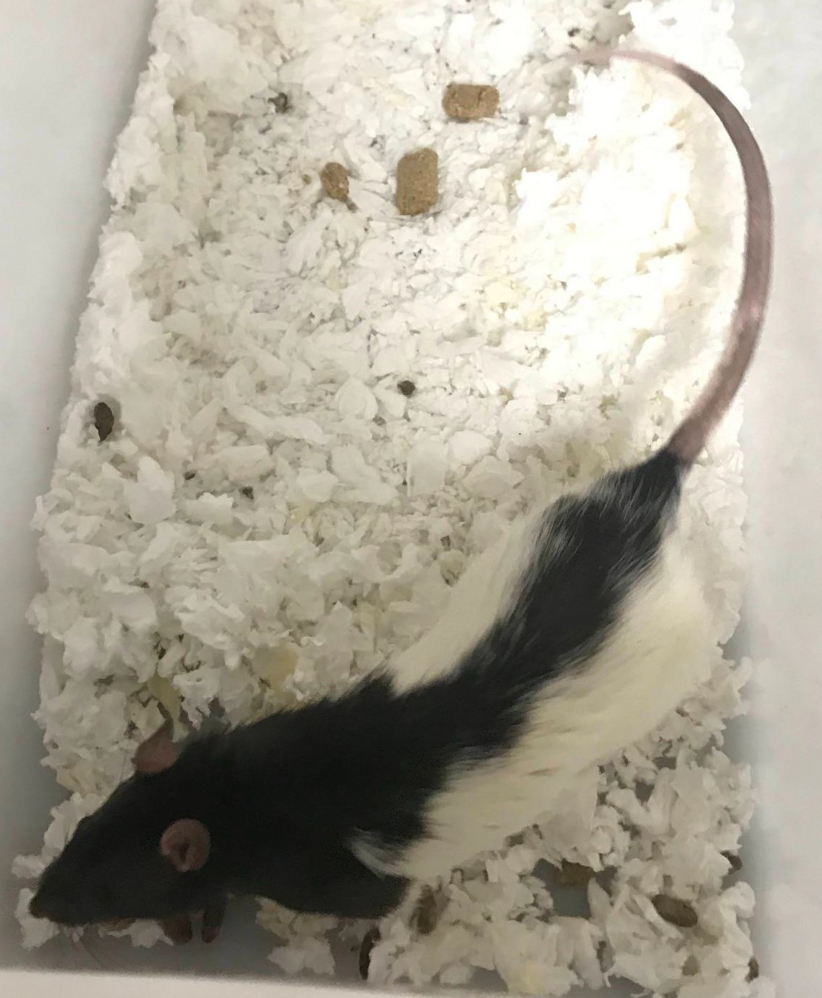
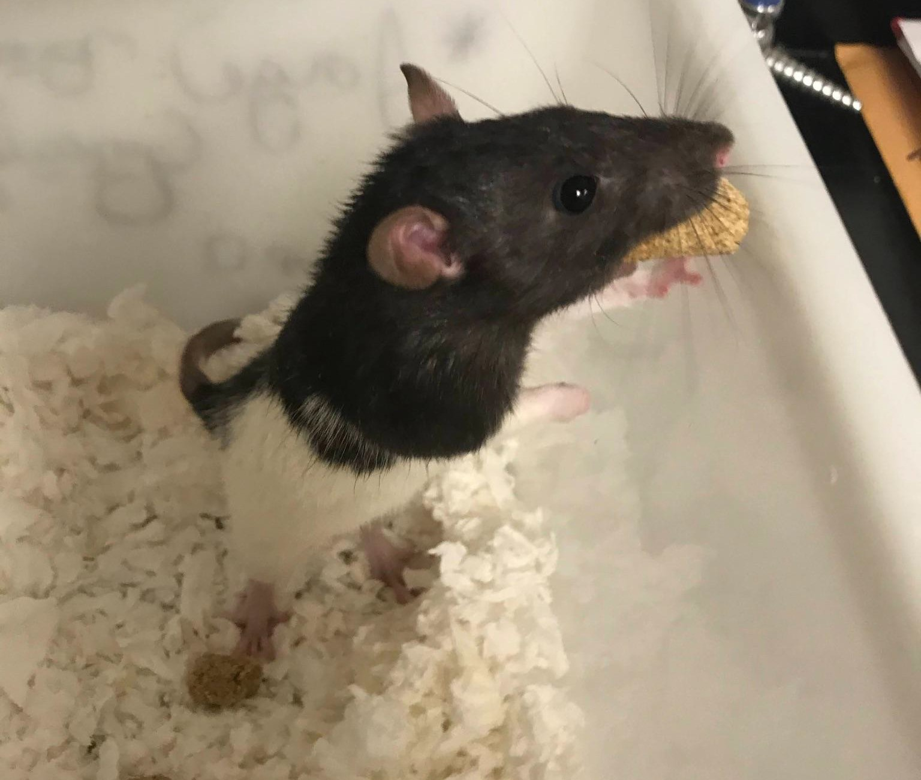

- Nutritive pellet diet and water for rats

- 16 water bottles

- 16 polypropylene tubs with cage-top lids that held water bottles
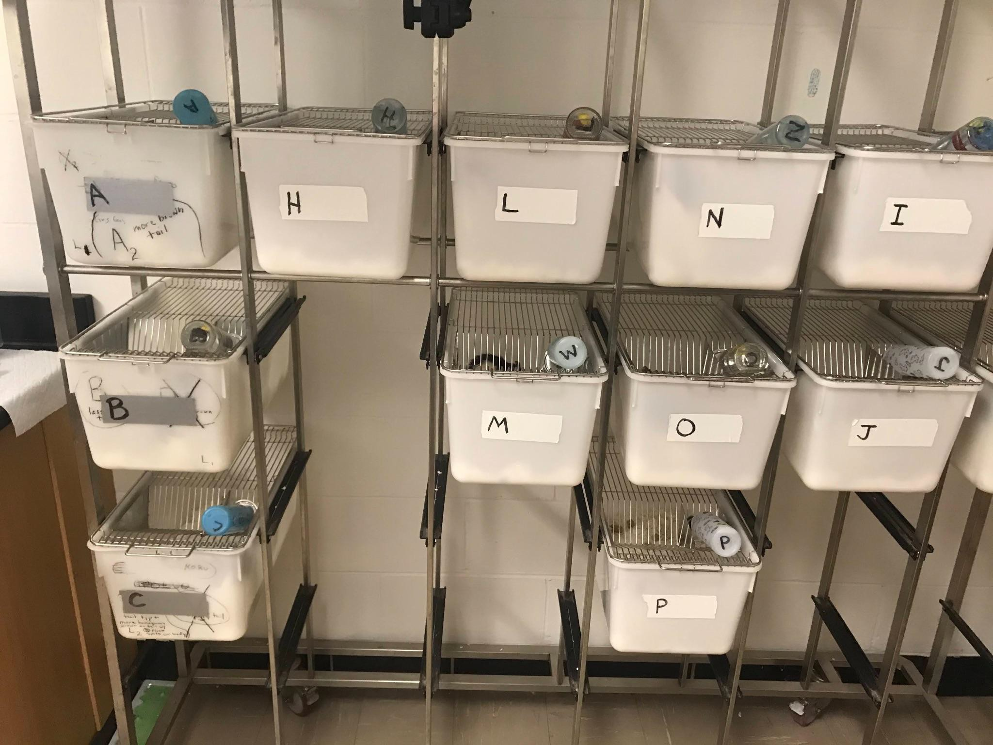

- Hypoallergenic sustainably produced paper bedding

Essential Oil Equipment

- Lavender essential oil in amber bottle

  - 1 mL lavender essential oil per test → (1 ml)(8 test subjects) = 8 mL lavender essential oil needed total

- Peppermint essential oil in amber bottle

  - (1 mL)(8 test subjects) = 8 mL peppermint essential oil needed total

- Distilled water

  - (1 mL)(32 trials) = 32 mL distilled water needed total

- Polyethylene bottle for distilled water storage

- Cotton balls

  - 1 cotton ball needed per trial (each cotton ball was soaked in 1 mL distilled water or lavender essential oil or peppermint essential oil per trial)
  - (3 testing days)(16 trials per day) = 48 total cotton balls needed

- 2 scent chambers (1 for lavender and 1 for peppermint)

  - I cleaned the lavender scent chamber with Oxivir™ surface disinfectant cleaner and then used it for Baseline 1 and 2.

Figure 8

Lavender (left, blue) and Peppermint (right, red) Scent Chambers used during Intervention
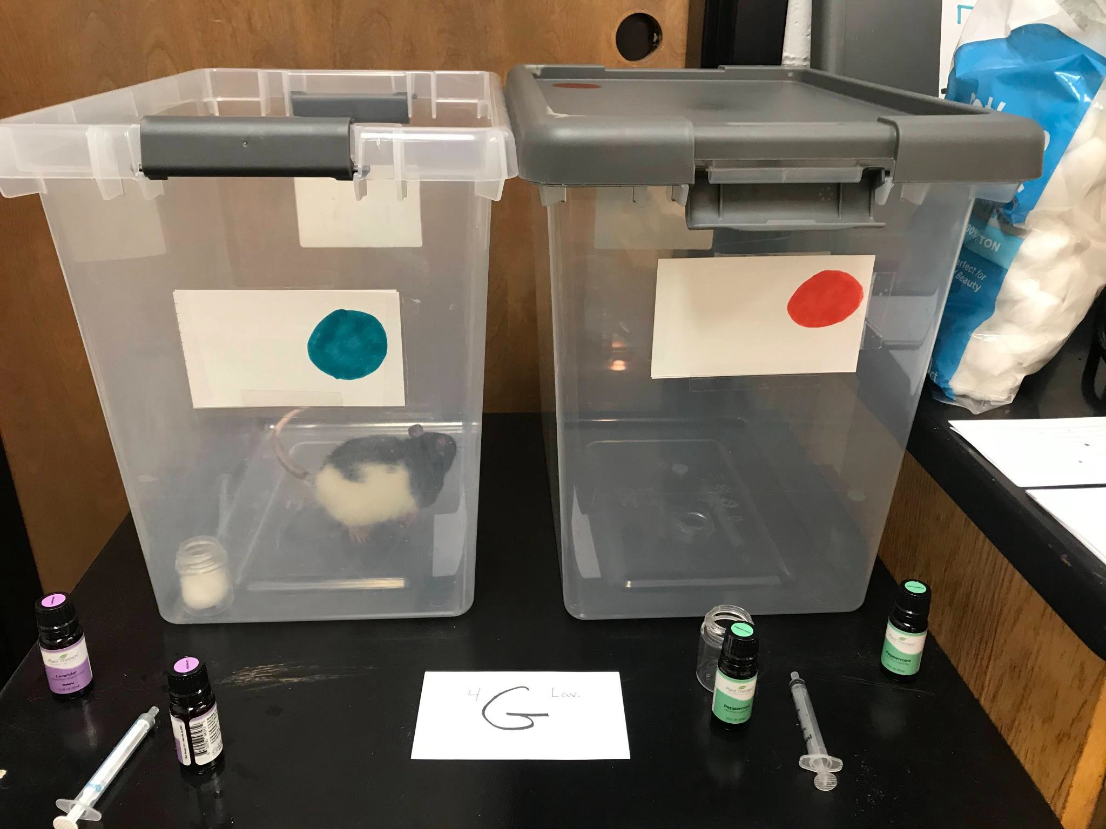

- 3 one mL syringes → used to soak cotton ball

Figure 9

Syringe
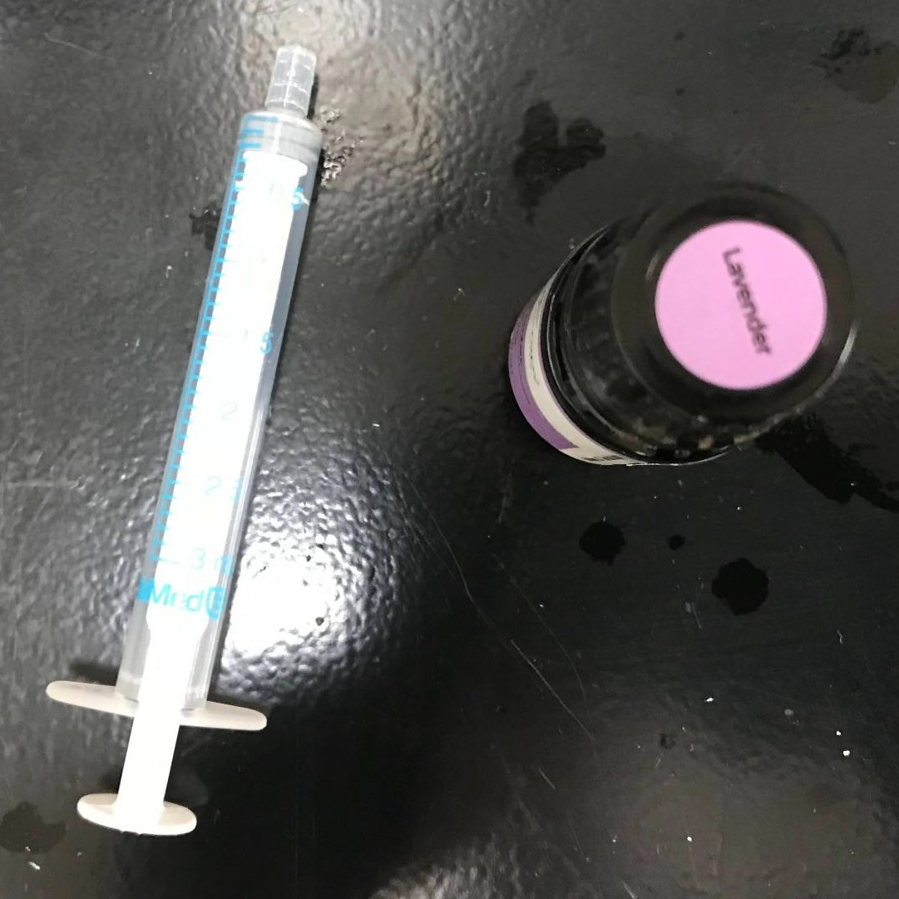

- 2 plastic containers → held cotton ball in each scent chamber

- Ionizer → I turned on the ionizer and placed it on the EPM for 5 minutes between each trial to remove scent residual.

Figures 10 and 11

Ionizer
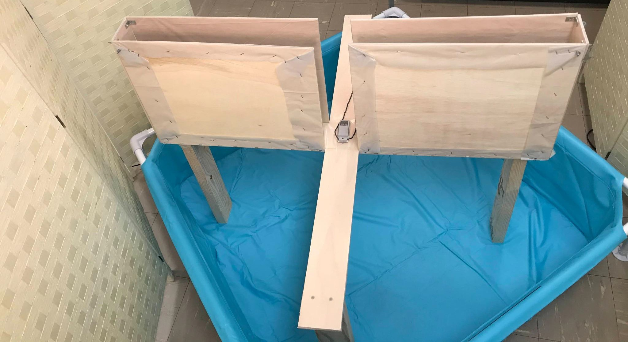

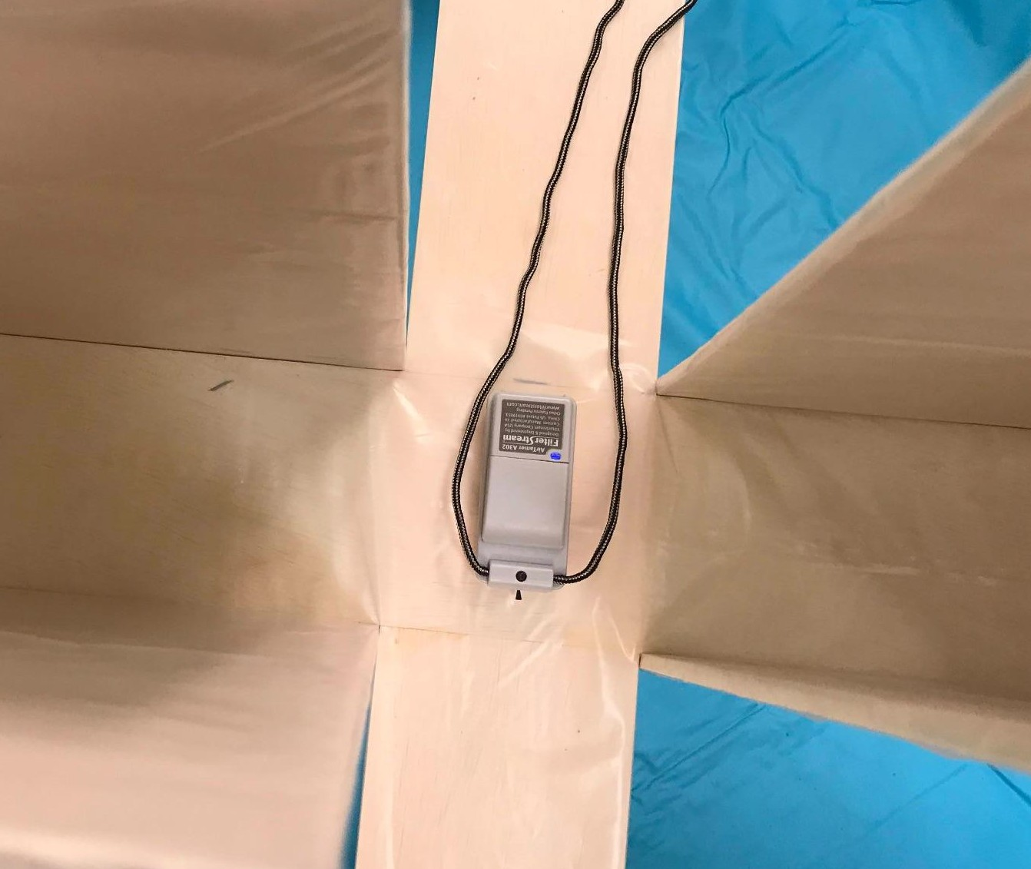

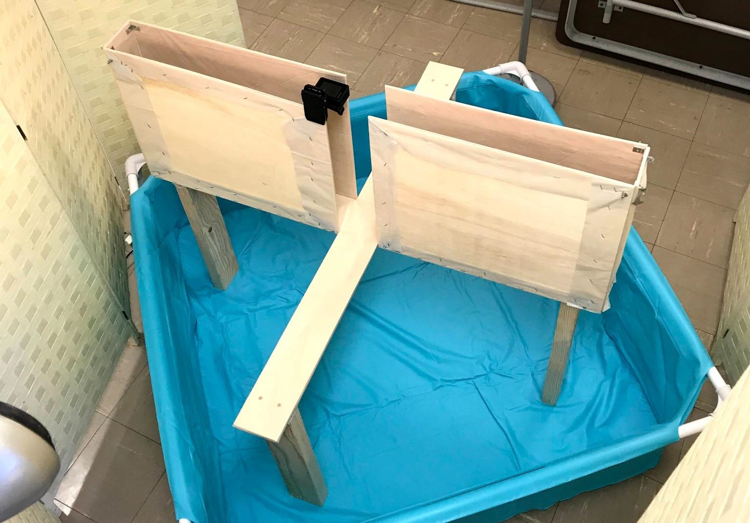
Elevated Plus Maze Equipment Figure 2 (also shown on page 13) Home-Constructed Elevated Plus Maze

Note. All measurements in Figure 2 are the same as in Figure 1.

- Camera → I used my phone for all recordings

- 2 Privacy screens → enclosed EPM from the rest of the room

Figure 12

Privacy Screen

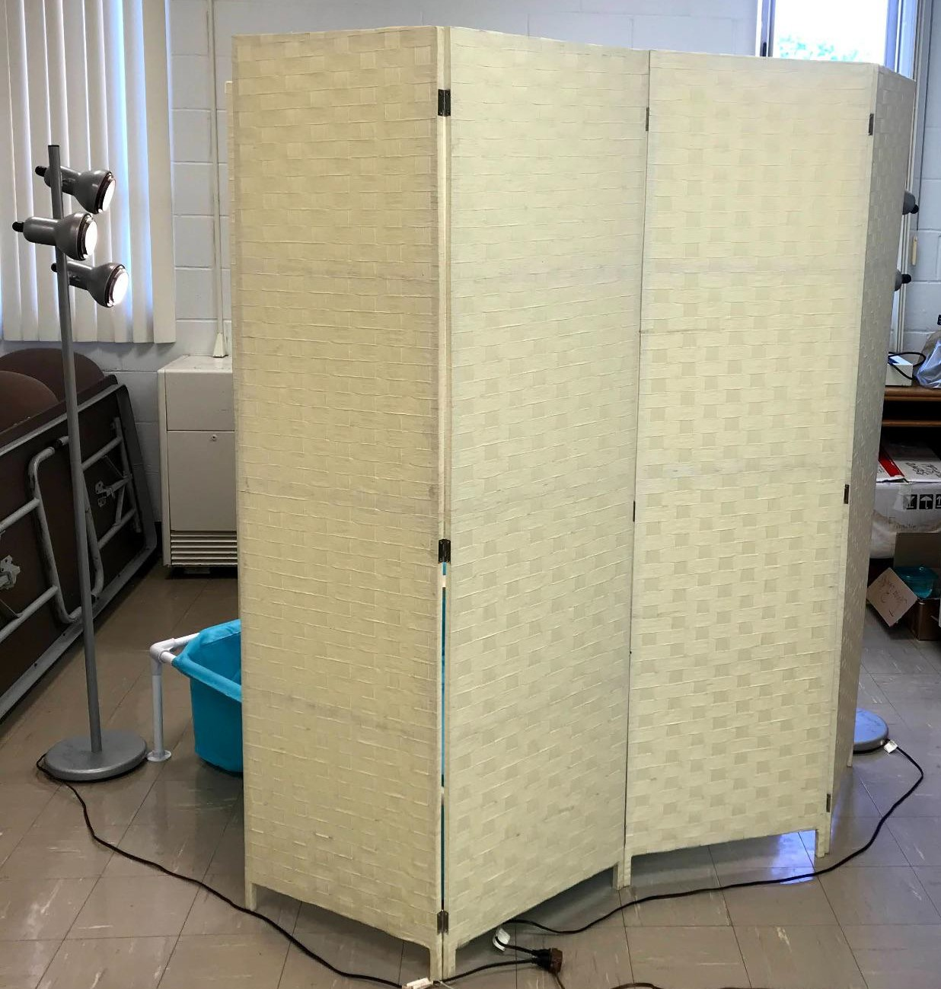

- 2 lamps with 3 light bulbs each (1 lamp facing each open arm)

Figure 13 and 14

Lamps
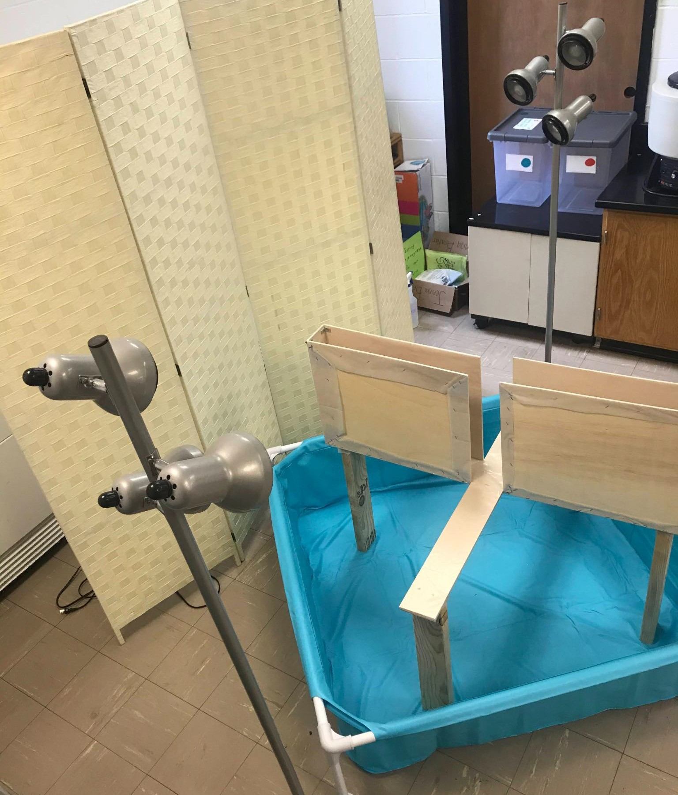

Note. Lamps were lit for EPM testing.

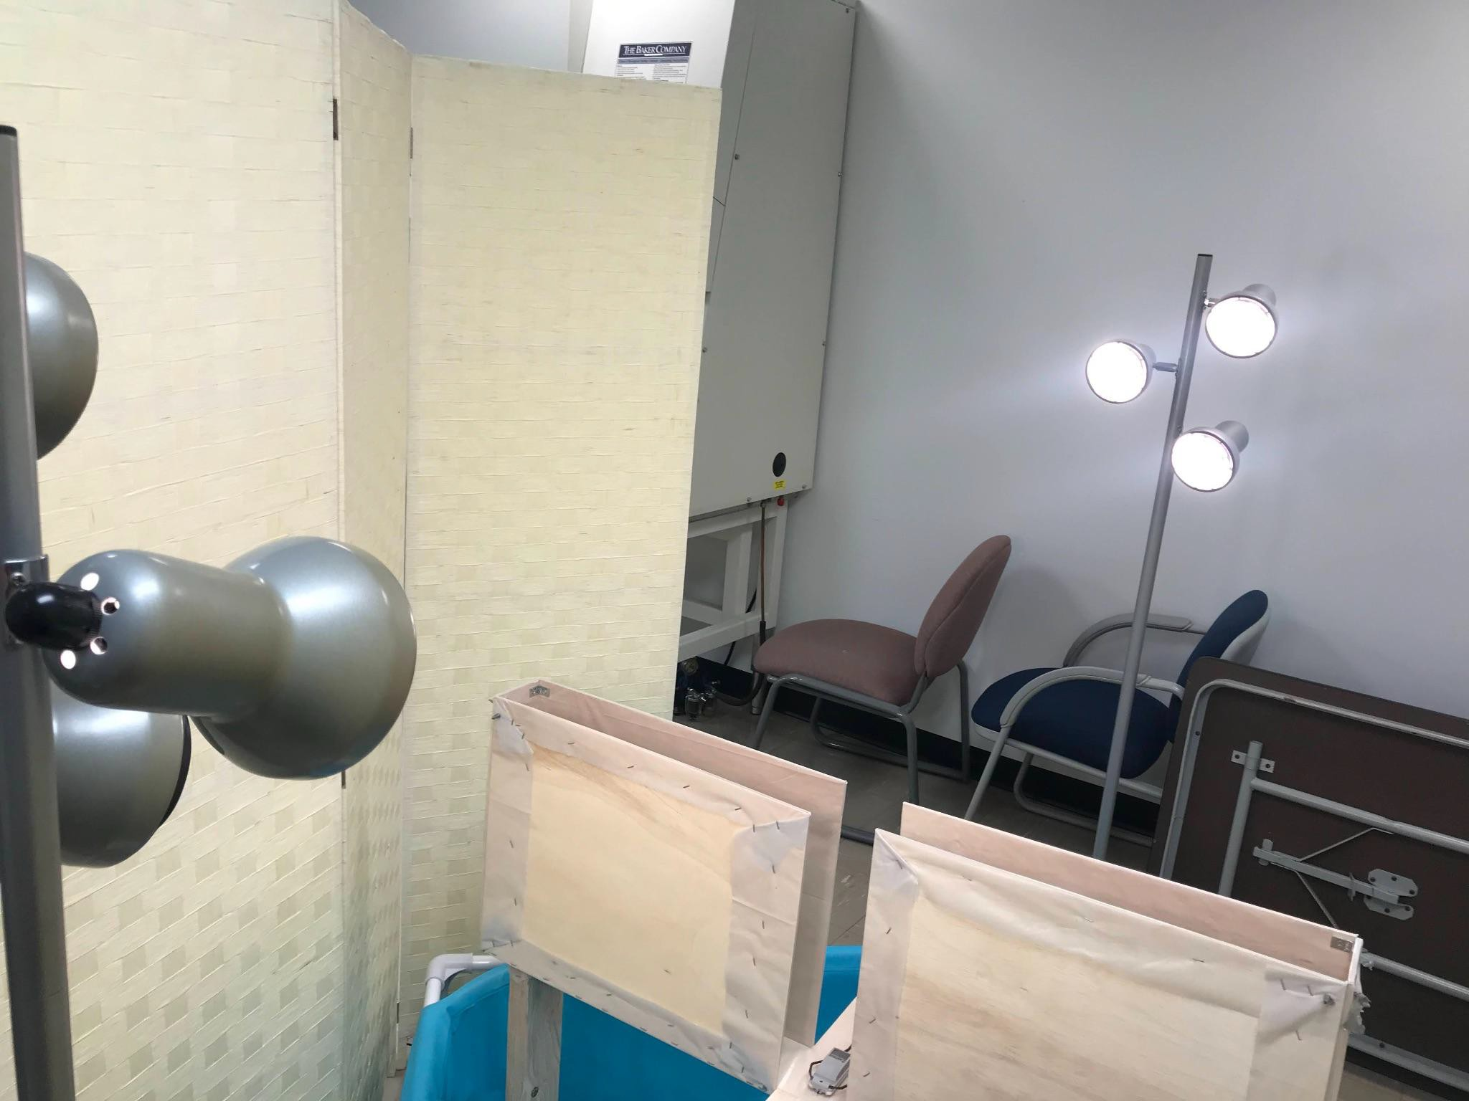

- Timer

- Plywood → built flooring and walls of EPM. Refer to Figure 1 (page 12) for dimensions of the EPM.
- Plastic sheeting → lined flooring and walls of EPM

- Wooden 2 x 4s → built the 4 legs of the EPM

- Drill

- Screws

- Measuring tape

- Saw

- Oxivir™ surface disinfectant cleaner → cleaned EPM between test subjects

References

Akbari, F., Rezaei, M., & Khatony, A. (2019). Effect Of Peppermint Essence On The Pain And Anxiety Caused By Intravenous Catheterization In Cardiac Patients: A Randomized Controlled Trial. Journal of pain research, 12, 2933–2939. https://doi.org/10.2147/JPR.S226312
American Psychological Association. (n.d.). Anxiety. American Psychological Association. https://www.apa.org/topics/anxiety#.
Anxiety and Depression Association of America, ADAA. (n.d.). Adult ADHD (attention deficit hyperactive disorder). Retrieved December 8, 2021, from
https://adaa.org/understanding-anxiety/related-illnesses/other-related-conditions/adult-adh d.
Anxiety and Depression Association of America, ADAA. (n.d.). Facts & Statistics. Retrieved December 8, 2021, from https://adaa.org/understanding-anxiety/facts-statistics.
Centers for Disease Control and Prevention. (2020, September 21). Treatment of ADHD. Centers for Disease Control and Prevention. https://www.cdc.gov/ncbddd/adhd/treatment.html.
Chioca, L. R., Antunes, V. D., Ferro, M. M., Losso, E. M., & Andreatini, R. (2013). Anosmia does not impair the anxiolytic-like effect of lavender essential oil inhalation in mice. Life sciences, 92(20-21), 971–975.
Elevated Plus Maze. Maze Engineers. (2020, November 25). https://conductscience.com/maze/portfolio/elevated-plus-maze/#apparatusandequipment.
Faber, J., & Fonseca, L. M. (2014). How sample size influences research outcomes. Dental press journal of orthodontics, 19(4), 27–29.
https://doi.org/10.1590/2176-9451.19.4.027-029.ebo

Fox, G. A., Torigoe, E., & Butcher, G. Q. (2018). Constructing an Inexpensive Elevated Plus Maze. Journal of undergraduate neuroscience education : JUNE : a publication of FUN, Faculty for Undergraduate Neuroscience, 16(2), R44–R47.
Göbel, H., Schmidt, G., & Soyka, D. (1994). Effect of peppermint and eucalyptus oil preparations on neurophysiological and experimental algesimetric headache parameters. Cephalalgia, 14(3), 228–234. https://doi.org/10.1046/j.1468-2982.1994.014003228.x
Lezak, K. R., Missig, G., & Carlezon, W. A. (2017, June). Behavioral methods to study anxiety in rodents. Dialogues in clinical neuroscience. https://www.ncbi.nlm.nih.gov/pmc/articles/PMC5573562/.
Lizarraga‐Valderrama, L. R. (2020, August 29). Effects of essential oils on central nervous

system: Focus on mental health. Wiley Online Library. https://onlinelibrary.wiley.com/doi/full/10.1002/ptr.6854.
Malcolm, B. J., & Tallian, K. (2018). Essential oil of lavender in anxiety disorders: Ready for prime time?. The mental health clinician, 7(4), 147–155. https://doi.org/10.9740/mhc.2017.07.147
Orkin. (n.d.). Natural rat deterrent. Author. https://www.orkin.com/pests/rodents/rats/natural-rat-deterrent
Sturman, O., Germain, P.-L., & Bohacek, J. (2018) Exploratory rearing: A context- and stress-sensitive behavior recorded in the open-field test. Stress, 21(5), 443-452. https://doi.org/10.1080/10253890.2018.1438405
Rousseau, J.B.I., Van Lochem, P.B.A., Gispen, W.H. et al. Classification of rat behavior with an image-processing method and a neural network. Behavior Research Methods, Instruments, & Computers 32, 63–71 (2000). https://doi.org/10.3758/BF03200789

Schmidt, E., Bail, S., Buchbauer, G., Stoilova, I., Atanasova, T., Stoyanova, A., Krastanov, A., & Jirovetz, L. (2009). Chemical composition, olfactory evaluation and antioxidant effects of essential oil from Mentha x piperita. Natural product communications, 4(8), 1107–1112.
Sestakova, N., Puzserova, A., Kluknavsky, M., & Bernatova, I. (2013). Determination of motor activity and anxiety-related behaviour in rodents: methodological aspects and role of nitric oxide. Interdisciplinary toxicology, 6(3), 126–135.
https://doi.org/10.2478/intox-2013-0020

Stanford Behavioral and Functional Neuroscience Laboratory. (n.d.). Elevated Plus Maze Standard Operating Procedure.
Stea, S., Beraudi, A., & De Pasquale, D. (2014). Essential Oils for Complementary Treatment of Surgical Patients: State of the Art. Evidence-Based Complementary & Alternative Medicine (ECAM), 2014, 1–6. https://doi.org/10.1155/2014/726341
U.S. Department of Health and Human Services. (n.d.). Peppermint Oil. National Center for Complementary and Integrative Health. https://www.nccih.nih.gov/health/peppermint-oil.
Walf, A. A., & Frye, C. A. (2007). The use of the elevated plus maze as an assay of anxiety-related behavior in rodents. Nature protocols, 2(2), 322–328. https://doi.org/10.1038/nprot.2007.44

