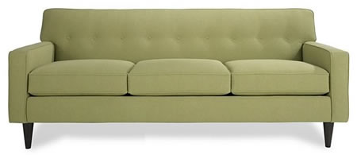
20TH ANNUAL September 26, 2019
DAVENPORT
Derby

Information Packet and Entry Form

Free Supplies
All supplies (couch, wheels, two 2x4s) will be available at no cost to you!

Rules
There are a few guidelines that all participants must observe:
- All couches must be at least 6 foot in length.
- All couches must be pushed, pulled, or carried.
- There can be no engines, machinery, or motors.
- The deadline for signing up is Friday, September 20th at 5:00pm .
- All entries must have a theme. There should be no one “just racing” a couch. Past themes have included Trojan Horse, Shark Week, Super Mario Brothers, and the Lion King just to name a few.
- The “Best in Show” category will be scored collectively, but the races will be divided by gender. If you have a mixed group, whichever gender is moving the couch will determine which race you are a part of!
- There must be at least four people on the couch that do not touch the ground for the entire race.
- All racers that cross the starting line, must cross the halfway line without impeding their opponent, and must cross the finish line again before being considered finished.
- Any intentional or unintentional sabotage to another team’s race progression will disqualify you.
- Racing tournament will be single elimination.

Race Day Information
- Race Day: Thursday, September 26th 2019
- Schedule for Race Day:
4:45 p.m.- couches must be in place (behind BCC) and ready for inspection.
5:00 p.m.- Introduction of the couches and themes
(You will get a 30 sec space to “act out” or encapsulate your theme).
- The competition will be tournament style so make your couch able to withstand multiple races. The tournament bracket will be finalized after couch inspections are done. The Davenport Derby staff reserves the right to structure the bracket in the way that best accomplishes the goals of the Derby.
- Trophies and prizes will be awarded to:
*First place Women
*First place Men
*Best in Show
- Questions or comments should be directed to
Logan Hansen lhansen@malone.edu

*The Davenport Derby staff reserves the right to make final decisions on the structuring of the Davenport Derby, including but not limited to the right to refuse entry for teams that have not followed one or more rules, the structure of the bracket, and the need to amend the rules or information as needed to accomplish the goals of the derby.

2019 Davenport Derby

Sign Up Sheet
Please return this completed form to the Student Development Office!

Name of team/theme____________________________

Name of Organization:______________________
(Ex. WWF, APO, Cross Country, etc)

Do you agree to all of the conditions as listed in the Rules and/or information sheet?
Yes / Yes (circle one)

Which Bracket? (Circle one)
Men Women

Team Leader/Contact Person:
(name)__________________________________________
(phone)_________________________________________
(email)__________________________________________

