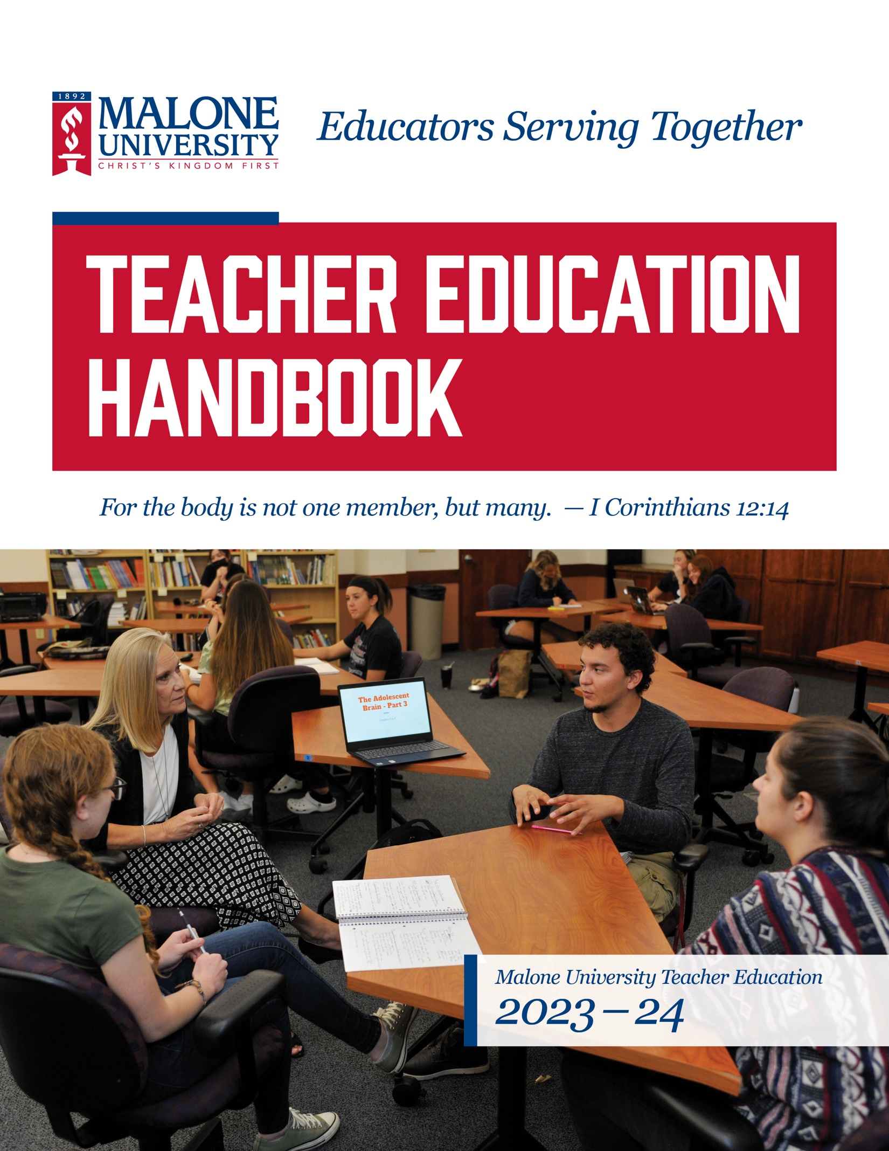

Malone University Teacher Education Student Handbook

Mission of Malone University
The mission of Malone University is to provide students with an education based on biblical faith to develop men and women in intellectual maturity, wisdom, and Christian faith who are committed to serving the church, community, and world.

Mission of Malone Teacher Education
In concert with the University’s mission, the mission of the Malone Teacher Education Program is to, in collaboration with liberal arts faculty and PreK - 12 educational partners provide a biblically based education which prepares knowledgeable, reflective, collaborative educators committed to serving others in order that all individuals may learn and develop to their fullest potential and interact with each other and their environment with respect, compassion, and fairness.

Motto of Malone Teacher Education
Considering this mission, the motto of the Malone Teacher Education (MTE) Program is “Educators Serving Together,” which is supported by our theme verse, I Corinthians 12:14, which says, “For the body is not one member, but many.” Educators must recognize that communities, including educational communities, are diverse and have unique values and needs.
Therefore, our purpose and goals are focused on preparing candidates committed to serving others collaboratively and who demonstrate through their knowledge, skills, and dispositions competencies which promote the growth of each learner.
Within the context of Christian faith, we endeavor to prepare teachers who are intellectually mature, reflective, collaborative, and wise. Teachers who are so equipped can then provide opportunities for all learners to develop to their fullest potential, enabling them to interact with others and their environment with respect, compassion, and fairness.
To this end we assess candidate performance outcomes (candidate proficiencies) through program admission criteria, assessment of candidate performance during study, in field/preclinical experience, student teaching/clinical experience, at program completion, and through alumni surveys and feedback from PreK-12 educational partners.

CAEP Accreditation
The School of Education and Human Development at Malone University is accredited by the Council for the Accreditation of Educator Preparation (CAEP) through spring 2024. Being CAEP accredited means that the teacher education programs meet rigorous standards set by the profession and members of the public. Institutions must demonstrate that their teacher candidates have in-depth knowledge of the subject matter that they plan to teach and the skills necessary to convey this content so that all students learn. As part of the accreditation process, the following Teacher Candidate Proficiencies were identified and are assessed.

Malone Teacher Education Candidate Proficiencies
We prepare candidates who:
- Demonstrate ways in which a Christian worldview informs educational practice.
- Apply sound principles of teaching, learning, and advocacy.
- Master the content for which they have educational responsibility.
- Demonstrate competence in the process of planning developmentally appropriate practices.
- Honor each person as made in the image of God and therefore use understanding of individual differences and diverse cultures and communities to enable each learner to meet high standards.
- Identify organizational and behavioral management strategies that create an educational environment conducive to effective learning and growth.
- Evaluate and support student learning and growth by utilizing varied assessments to inform instruction and interventions.
- Display professionalism and ownership of professional growth.
- Use technology as a tool for assessment, instruction, communication, collaboration, and creativity.
- Collaborate with teachers, families, community, and other stakeholders in student learning and growth.
- Initiate and sustain all communication in an organized, clear, and confident manner, using Standard English.
- Exhibit dispositions for educators committed to serving together by:
  - Providing service,
  - Practicing fairness,
  - Promoting stewardship,
  - Believing all students can learn and grow to their full potential.

Additionally, the Malone Teacher Education Candidate Proficiencies are intentionally aligned with the Ohio Standards for the Teaching Profession (OSTP).

These Ohio Standards for the Teaching Profession include:
1. Teachers understand student learning and development and respect the diversity of the students they teach. (Malone CP 2, CP 4, CP 5, CP 12)
2. Teachers know and understand the content area for which they have instructional responsibility. (Malone CP 3)
3. Teachers understand and use varied assessments to inform instruction, evaluate and ensure student learning. (Malone CP 7, CP 9)
4. Teachers plan and deliver effective instruction that advances the learning of each individual student. (Malone CP 2, CP 4, CP 5, CP 9, CP 11)
5. Teachers create learning environments that promote high levels of learning and achievement for all students. (Malone CP 6, CP 12)
6. Teachers collaborate and communicate with students, parents, other educators, administrators, and the community to support student learning. (Malone CP 9, CP 10)
7. Teachers assume responsibility for professional growth, performance, and involvement as an individual and as a member of a learning community. (Malone CP 1, CP 8)
(Ohio Department of Education, 2018- Ohio Standard 7 of the OSTP)

Teacher Licensure Programs
Malone University is approved by the Ohio Department of Higher Education to offer Teacher Education Programs in the following licensure areas:

Primary Childhood Education (PCE): The Primary Childhood Education (PreK - 5) major is designed for teacher candidates who wish to receive the Primary Childhood License, valid for teaching children in prekindergarten (from age 3) through grade 5. Candidates selecting this licensure program must take 12 semester hours of reading, including a phonics course. Candidates are required to earn a minimum grade of C for all EDUC and SPED courses and may repeat a course only once. In addition to required coursework, successful completion of field experience hours and a full semester of student teaching are required to meet program requirements. Candidates are expected to complete all documentation tasks related to coursework and clinical field experiences in Tevera by the end of the semester in which the course and/or experience was completed. The Intervention Specialist license (see below) can be added to the PCE license with the completion of the following additional courses: SPED 253, SPED 376, and SPED 405. In addition, required and cross-listed courses EDUC 293 and 425 must be taken as SPED 293 and SPED 425.

Intervention Specialist: Mild/Moderate Educational Needs (IS): The Intervention Specialist: Mild/Moderate Educational Needs (K - 12) major is designed for teacher candidates who wish to receive the Intervention Specialist: Mild/Moderate License, valid for teaching children from ages 5 -
21 and grades K - 12 who have mild or moderate educational needs. Candidates selecting this licensure program must take 12 semester hours of reading, including a phonics course. Candidates are required to earn a minimum grade of C for all EDUC and SPED courses and may repeat a course only once. In addition to required coursework, successful completion of field experience hours and a full semester of student teaching are required to meet program requirements.

Middle Childhood Education (MCE): The Middle Childhood Education (4 - 9) major is designed for teacher candidates who wish to receive the Middle Childhood License, valid for teaching children from ages 8 - 14 and grades 4 - 9 in the curriculum areas named in such license. This program includes preparation in at least two (2) of the following concentration areas: Mathematics, Science, Social Studies, and Reading/Language Arts. The teacher is licensed to teach in only the selected areas. Candidates selecting this licensure program must take 12 semester hours of reading, including a course in phonics. Candidates are required to earn a minimum grade of C for all EDUC and SPED courses and may repeat a course only once. In addition to required coursework, successful completion of field experience hours and a full semester of student teaching are required to meet program requirements. The total number of semester hours required for each of the four concentrations is as follows: Mathematics- 21 hours, Science- 26 hours, Social Studies- 24 hours, Reading/Language Arts-18 hours.

Adolescence to Young Adult (AYA): The Adolescence to Young Adult Education program (7 -12), is designed for teacher candidates who wish to receive a license valid for teaching students from ages 12-21 and grades 7 - 12 in the curriculum area(s) named on the license. Malone University does not have a major called “Adolescence to Young Adult Education.” The major will be the chosen curriculum area. Candidates are required to earn a minimum grade of C for all EDUC and SPED courses and may repeat a course only once. In addition to required coursework, successful completion of field experience hours and a full semester of student teaching are required to meet program requirements. Candidates selecting this licensure program are required to take Reading in the Content Area – 3 semester hours, including preparation in dyslexia (ODHE), and one special education course, along with other professional education coursework. Curriculum areas that constitute a major for grades 7 - 12 are:

Integrated Language Arts: The Integrated Language Arts major is designed to prepare candidates for teaching grades 7 - 12 in such subject areas as English, speech, journalism, and communications.

Integrated Mathematics: The Integrated Mathematics major is designed to prepare candidates for teaching grades 7 - 12 in mathematics subject areas typically found in the 7 - 12 curricula.

Integrated Social Studies: The Integrated Social Studies major is designed to prepare candidates for teaching grades 7 - 12 in such subject areas as history, economics, political science, and sociology. Candidates selecting this major will take the social studies core and one of the following concentrations: History, Political Science, or Sociology.

Life Science/Chemistry: The Life Science/Chemistry major is designed to prepare candidates for teaching grades 7 - 12 in sciences; biology, chemistry, human anatomy, physical science, and environmental science.

Life Science: The Life Science major is designed to prepare candidates for teaching grades 7 - 12 in biological sciences including biology, human anatomy, physical science, and environmental science.
*Link to ODE description of AYA science areas.

Multi-Age License (MA): The Multi-Age License (PreK -12) program is designed for teacher candidates who wish to receive the Multi-Age License in the curriculum area named on the license and is valid for teaching students from ages 3 - 21 and grades PreK - 12. Malone University does not have a major called “Multi-Age Education.” The major will be the chosen curriculum area. Candidates selecting this licensure program are required to take Reading in the Content Area – 3 semester hours, including preparation in dyslexia (ODHE) and one special education course, along with other professional education coursework. Candidates are required to earn a minimum grade of C for all EDUC and SPED courses and may repeat a course only once. In addition to required coursework, successful completion of field experience hours and a full semester of student teaching are required to meet program requirements. Curriculum area that constitutes a major for a multi-age license: *Music Education.

Passing through the Gateways
CAEP accreditation standards require that candidates are reviewed at specific points in their programs and meet certain predetermined criteria before they continue their preparation in teacher education. These specific points are called Gateways. The Malone University Teacher Education Program has identified three Gateways: I. Admission to Teacher Education, II. Candidacy for Clinical Experience, and III. Recommendation for Licensure and Professional Practice.

I. Admission to Teacher Education: The application for Teacher Education is typically completed during the semester in which EDUC 232 is taken. To be admitted to Teacher Education a candidate must:
- earn a minimum grade of C (2.0 average) for all EDUC and SPED courses (Students may repeat a course only once)
- have a minimum cumulative GPA of 2.75,
- have a minimum grade of B- in COMM 110,
- have completed EDUC 112 (114 for transfer students), EDUC 232 and EDUC 122,
- have satisfactory Disposition Assessments (see p.8),
- have satisfactory recommendations from faculty, and
- have no outstanding Professional Concerns (see p.8)

No 300 level education courses (EDUC or SPED) may be taken until a candidate has been admitted to Teacher Education.

Dispositional Evaluations: Candidate Proficiency #12 includes four dispositions that have been identified as requisites for Malone University teacher candidates: providing service, practicing fairness, promoting stewardship, and a belief that all students can learn.
• Providing service implies that one is a servant, and one who serves seeks to make sure that others’ needs are met.
• Practicing fairness begins with empathy and a concern for others. Empathy for others includes valuing everyone’s diverse background and gifts.
• Promoting stewardship includes accountability, and educators are indeed accountable to society for the well-being of our future. From a Christian worldview, not only are educators accountable to society, but they are also responsible to use their talents, abilities, resources, and intellectual capabilities in such a way that they bring glory to God.
• A belief that all students can learn is reflected by educators who nurture their students and let these students know they genuinely care about them. It also includes a commitment to helping each student learn and grow regardless of students’ backgrounds, abilities, cultural traditions, religious practices, and patterns of interaction.
Candidates are evaluated using a dispositions rubric at the beginning, middle, and end of their teacher education program. It is expected that candidates achieve scores indicating a sensitivity to said dispositions during exploratory field experiences, inclination during preclinical field experiences, and application during the clinical field experiences. (See the chart below for satisfactory Assessment of Dispositions scores.)

Professional Concerns Related to Candidate Performance: Professional Concern Conferences (PCCs) are held for candidates whose dispositional or pedagogical performance warrants intervention. These conferences are attended by the candidate and appropriate faculty members. Occurrences that would activate a professional concern conference include, but are not limited to:
• A “Do not recommend” designation on an Admission to Teacher Education recommendation.
• Any score of 0 or unacceptable in any area on a field or clinical evaluation/disposition form.
• Demonstration of inappropriate behavior in a Malone course.
• Demonstration of inappropriate behavior in a Malone field experience.
- Transfer students will be required to provide documentation of good standing at their previous university if field hours were completed.

Teacher Education Committee reviews and acts on all applications to Teacher Education. *Professional Education majors are not required to apply for Teacher Education. All course field requirements are in place except for Clinical Experience.

II. Candidacy for Clinical Experience: The required Clinical Experience is accomplished through a full semester of Student Teaching. The Application for Student Teaching is completed during the fall semester of the year before the student teaching is to be completed. The Teacher Education Committee reviews all applications to Candidacy for Clinical Experience and acts on acceptance to the clinical experience. See the chart below for specific criteria.

III. Recommendation for Licensure and Professional Practice: The application for teacher licensure is submitted to the Ohio Department of Education (ODE) upon completion of the Teacher Education Program, graduation, and passage of the required Ohio Assessments for Educators Examinations. The Chair of the Department of Education signs the approval of all applications before they are sent to ODE. See the chart below for specific criteria.
Overview of Malone University Teacher Education
Undergraduate Gateways leading to Licensure

Gateways |  | Candidate Assessment | Criteria | Gatekeeper
One | Admission to Teacher Education | - Academic achievement  - COMM 110  - EDUC/SPED Course Grades  - EDUC 112 (114 for transfer students), 232, and EDUC 122  - Dispositions  - Field experience evaluations  - Faculty recommendations  - Professional concerns | 1. Cumulative 2.75 GPA  2. Completed: Yes or No  3. B- grade or better in COMM 110  4. Earn a minimum grade of C (2.0) for all  EDUC and SPED courses (Students may repeat  a course only once)  5. Completed: Yes or No  6. Satisfactory evaluation/disposition assessment (no scores of 0 or Unacceptable) or resolved via PCC*  7. Two designated recommendations:  (No=Must be resolved via PCC*)  8. None or resolved via PCC*: Yes or No | Teacher Education Committee
Two | Candidacy for Clinical Experience | 1. Admission to teacher education  2. Academic achievement  3. Academic achievement in major  4. EDUC/SPED Course Grades  5. Field experience evaluations  6. Faculty Recommendations  7. Professional concerns | 1. Accepted: Yes or No  2. Cumulative 2.75 GPA  3. Major 2.75 GPA  4. Earn a minimum grade of C (2.0) for all  EDUC and SPED courses (Students may  repeat a course only once)  5. Satisfactory evaluations/dispositions (no scores of Unacceptable in any area): (No=Must be resolved via PCC*  6. Two designated recommendations:  Yes or No (No=Must be resolved via PCC*  7. None or resolved via PCC*: Yes or No | Teacher Education Committee
Three | Recommendation for Licensure  & Professional Practice | 1. Admission to clinical experience  2. Academic achievement  3. Academic achievement in major  4. Clinical Evaluation  5. Dispositions  6. Meets all state requirements for licensure.  7. Degree requirements  8. Professional concerns | - Accepted: Yes or No  - Major 2.75 GPA  - Satisfactory CPAST evaluation (no scores of 0 or unacceptable in any area): (No=Must be  resolved via PCC*)  - Satisfactory student teaching assessment (no scores of 0) or resolved via PCC*  - Pass: Yes or No  - All completed: Yes or No  - Completed all University requirements for degree.  - None or resolved via PCC*: Yes or No | Chair of Teacher Education

*PCC = Professional Concern Conference

State of Ohio Department of Education (ODE) Testing Requirements
The State of Ohio has adopted tests developed by Pearson Evaluation Systems entitled the Ohio Assessments for Educators as the program exit tests for teacher candidates in the state. All Ohio Assessments for Educators tests required by the State of Ohio must be passed before the application for teacher licensure is submitted to the State of Ohio by Malone University. The Ohio Assessments for Educators exams are very challenging and require that candidates prepare thoroughly before taking the tests. Candidates can obtain helpful test information including test preparation materials from the Ohio Department of Education (ODE) website: http://education.ohio.gov/Topics/Teaching/Licensure/Prepare-for-Certificate-License/Educator-Licensure-Examinations

Exploratory Field and Preclinical Experiences

CAEP accredited teacher education programs are required to include field experiences that are logical, sequential, planned, supervised, and evaluated. They must begin early in the program and take place in a variety of school settings. Field experiences are attached to several courses in the program and are designed to facilitate the application of course content in real life educational settings. Some field experiences are completed in public school partnership settings, and some are completed in private school settings. The intent of each partnership is to intentionally connect specific course content with actual practice in settings where it is being practiced. An evaluation is completed at the end of each field experience by the cooperating teacher(s) at the assigned school.

Before beginning a field experience, a candidate must submit a negative (meaning no evidence of criminal misconduct) Bureau of Criminal Investigation & Identification (BCII) fingerprint report. The BCII fingerprinting is offered at the start of every semester at the students’ expense. Results are stored at Administrative Services Office of Founders Hall (FH 20). BCII fingerprint reports are valid for one year. Failure to complete this requirement in a timely manner will jeopardize the field placement. For more information refer to the Field Handbook.
- What to Bring with You to Your BCI/FBI Background Check Appointment
- the two waiver forms filled out (unless you are going to come early) Copies of these forms are available hanging in a file folder on the bulletin board outside of the HUB as well as in the file folder hanging on the office door of the clinical and field coordinator. RH 300
- a valid (legal) ID such as a driver's license / passport
- Know your FULL Social Security Number
- Payment for $65 in Full either by: Check made out to "A-1 Background Check", CASH - exact change, or you may charge it to your student account (bring your student ID / number).

Placement Information: The field experience program coordinator and/or course instructor works with school placement coordinators to place teacher candidates into appropriate field experiences. Students may not contact schools or teachers directly to request placement. Many details must be taken into consideration for each person’s placement, including licensure area, required diversity in grade levels and content areas, urban requirements, transportation requests, conflicts of interest as well as how many teacher candidates are being placed in a district or school. Students may present a placement they are interested into the placement coordinator for consideration, but setting up placements independently may lead to a delay or withdrawal from placement. Potential conflicts of interest of placement may include completing an experience in the school in which the teacher candidate attended (any age K-12); completing experience in a school where family/friend works or attends; or completing where the teacher candidate is employed unless approved by field experience coordinator and/or course instructor.

Placement Type Requirements: All students are required to have a minimum of one urban, suburban, and rural placement in a major field experience. Early field experiences, such as Methods courses, are not included in meeting this requirement. We try to place students in these types of settings so that each setting can be observed equally and provide new opportunities that may not have been personally experienced prior to college.

Candidate Proficiencies: The Malone University School of Education & Human Development has established proficiencies for our teacher candidates, which are observed, supported, and evaluated throughout the teacher preparation program. In field-based experiences, we implore cooperating teachers to be an active part of supporting our candidates’ development in these proficiencies. The proficiencies are listed on page 3 of this handbook.

Expectations and Code of Conduct for Malone Candidates in Field Placements: The teacher candidate serves as a representative of Malone University during field/preclinical, and student teaching/clinical experiences and will be expected to uphold the philosophical tenets upon which Malone University is based. The Student Code of Conduct Policy found in the Malone University Student Handbook has established the standard of conduct expected of those who attend Malone. In addition, the School of Education and Human Development at Malone University desires to make clear a code of conduct particularly relevant to all those in teacher education.
*No student information will be shared with anyone, including family members or parents, unless permission is given. Sharing information violates the FERPA regulations.

Definitions
- Teacher Candidate = university student enrolled in a program leading to a teaching license in the State of Ohio.

- Field/Preclinical and Student Teaching Experiences/Clinical = course requirements that place the teacher candidate in an educational environment that includes a certified teacher and children assigned to the respective teacher by a school or district chartered by the State of Ohio. The teacher candidate will perform in the role of the classroom teacher and should exhibit professional behaviors expected of a practicing teacher.

- Cooperating Teacher = P-12, employed classroom teacher where field hours are completed.

- University Supervisor = university assigned professional who is licensed as an administrator or in the content area of the of student being supervised

All relationships and interactions between teacher candidates and those in the field/preclinical and student teaching/clinical experiences, including both candidates and staff members, must always be of a strictly professional nature and appearance. A Professional Concern Conference (PCC) will be held when the teacher candidate is reported to be:
1. displaying inappropriate covert or overt behaviors,
2. displaying romantic involvement with a minor (under age 18),
3. involved at a non-school sponsored or social event (e.g., party at a student’s home),
4. displaying inappropriate physical contact: (e.g., holding the hand of a four-year-old child is different from holding the hand of a middle or high school student),
5. using inappropriate nonverbal, verbal, or written communications,
6. displaying contact with a classroom student on school grounds in an area not observable by others.
7. providing transportation of students under the age of 18 which is prohibited.

Teacher candidate’s use of Internet activities and fair use of copyright materials.
1. Viewing Internet activities: Teacher candidates should be vigilant and responsible during the viewing and use of Internet materials while supervising classroom students of all ages. Viewing or accessing inappropriate Internet materials by classroom students under the supervision of teacher candidates would have a detrimental effect on the teacher candidate and Malone University. Any inappropriate activity related to the above would be cause for disciplinary action by the University and could result in legal action by the State of Ohio.
2. Using copyrighted materials: Teacher candidates should view their position as a role model to classroom students of all ages as to the “Fair Use” of printed and electronic materials. Even though educators enjoy a certain degree of latitude regarding the use of printed and electronic materials, they must be always mindful that they are constantly viewed by our classroom students as a benchmark for using copyrighted materials. Any inappropriate activity could be cause for disciplinary action by the University and/or result in legal action taken by the State of Ohio.
3. For additional information regarding “Fair Use” of copyrighted materials, visit the NEA Office of Education website here: http://www.nea.org/home/827.htm

Consequences for Code of Conduct violations:
1. Code of Conduct infractions could be career ending. One or more of the following actions by the Malone School of Education and Human Development may result:
a. Prohibit acceptance into the academic major.
b. Prohibit acceptance into teacher education.
c. Prohibit acceptance into student teaching/clinical.
d. Removal from field/preclinical and student teaching/clinical experiences.
e. Prohibit the State of Ohio from issuing a teaching license.
2. Action taken by Malone University for Code of Conduct violations could include withdrawal, suspension, or expulsion.

Use of Social Media: Candidates are urged to use extreme caution when using social media such as Facebook, Instagram, Snapchat, Twitter, etc. It is becoming more common for employers to search websites such as Google to get more information about potential employees. Even if one does not post pictures of oneself on Facebook, others may do so and “tag” them (put their name on the picture) for others on the network to see. Here are some strong suggestions when it comes to social media:
• Candidates should conduct themselves with integrity in all situations since one does not know when someone is taking a picture of them with a cell phone.
• Realize that someone can take screenshots of chat conversations and send them to Malone or an employer (this HAS happened).
• Posting pictures of K12 students or information about placement school on personal social media outlets is prohibited.
• Never give out a personal phone number to a student in field experiences/student teaching or “friend a student in a field experience/student teaching.

Attendance: Candidates are expected to arrive on time and on the days arranged for their field placement. Time records must be kept accurately and signatures from the cooperating teacher are required on the Malone Timesheet Template. As a professional courtesy, any absences, regardless of whether excused or not, require the teacher candidate to either call or e-mail the school site ahead of time. Candidates are to follow all school procedures for visitor identification (sign in, wearing of visitor identification).

Professional Demeanor: Candidates are expected to conduct themselves in a professional manner, avoiding gossip and negativity while promoting collegiality and a collaborative spirit. No cell phone or other electronic device usage is to be used during field hours unless directed/permitted by the cooperating teacher or being used for recording purposes. Dress is to be appropriate for a school environment and must adhere to the individual school guidelines. Candidates are to show initiative and take responsibility in their assigned placement(s). They are to exhibit a commitment to service, fairness, and stewardship and to demonstrate the belief that all students can learn and grow. Students are required to complete the Professionalism Module in Malone University’s Moodle Platform
The Role of the Cooperating Teacher
Mentoring: We are grateful for the cooperating teacher’s role as a mentor to a Malone teaching candidate as the cooperating teacher serves as a partner in the development of our licensure seekers. In any/all ways possible it is desired for the cooperating teacher to provide a positive model of professionalism and offer support and example to the candidate regarding how to teach, manage a class, and fulfill a variety of related roles as an educator. In these field experiences, it will be most helpful for cooperating teachers to provide multiple opportunities for the Malone candidate to observe, interact with students, and teach in a variety of contexts (e.g. small and whole group, one-on-one instruction, etc.).

Cooperating Teacher Information: The cooperating teacher will be emailed a link by the clinical and field coordinator for them to disclose background information and credentials required by CAEP for data reporting purposes.

Attendance records: The Malone candidate will present the cooperating teacher with a folder, which includes: an introductory letter, an attendance record, and the continuum of responsibilities. This should be reviewed by the candidate and the cooperating teacher within the first week of the field placement. Time is to be recorded to the nearest quarter of the hour weekly and initialed by the cooperating teacher upon each visit. Candidates are encouraged to take a photo of this time sheet each week in the event of loss of this very important document. The completed hours will be verified by the placement of the cooperating teacher’s full signature as well as the candidate’s full signature at the bottom of the form at the end of the field placement when all required field hours have been fulfilled. The candidate is responsible for the electronic submission of the time sheet to the university. The teacher candidate will not receive a passing grade for the course without the signed time/attendance sheet.

Candidate evaluations: The cooperating teacher electronically completes a midterm and a final evaluation in Tevera. The evaluation is accessed via a link sent from the university data professional to the cooperating teacher’s school email address at the midterm and final point of the field experience/semester. The midterm consists of a few short, “always, usually, rarely” responses. The final evaluation reflects upon the perceptions of the candidate’s performance in a variety of areas. All areas require a numerical score. Areas, which reflect more responsibility than expected of a field candidate, should be evaluated based on the candidate’s engagement through questioning and discussion with the cooperating teacher. *Complete the final evaluation after the candidate has completed the required field hours.

Student Teaching/Clinical Experience

The student teaching/clinical experience is usually done during the senior year. Teacher candidates must complete all courses in their selected major and all professional education courses before the student teaching/clinical experience begins. The candidate registers for EDUC 492 the 15-week (minimum of 450 clock hours) student teaching/clinical experience (12 semester hours), and EDUC 464 Student Teaching Seminar (3 semester hours) during the student teaching semester. No other coursework is to be taken during the student teaching semester. All student teaching applications are due in the fall semester preceding the school year in which the student teaching will take place.

Student Teaching Overseas: It may be possible to arrange a student teaching assignment in a location outside the United States. Malone University has a working relationship with schools through the Christian College Teacher Education Coordinating Council (CCTECC). If interested in this possibility, candidates should contact the Director of Field and Clinical Experiences.

Evaluation of Student Teaching/Clinical Experience:
Student teaching/clinical experience observation and evaluation forms focus on assessment criteria that Resident Educators (teachers in first two years of teaching) must be able to demonstrate to trained observers during the first two years of a full-time teaching position. This includes written observation forms, formative Mid-term and Final (summative) evaluation forms that include knowledge, skills, and dispositions expected of teacher candidates, and narrative evaluations from both the cooperating and supervising teachers.

Teacher Performance Assessment: The Teacher Performance Assessment (edTPA) is an assessment of teacher candidates, which is required by the State of Ohio. It is a performance-based assessment completed during student teaching that is focused on student learning and requires three basic tasks: (1) Planning for Instruction and Assessment, (2) Instructing and Engaging Students in Learning, and (3) Assessing Learning. The edTPA includes a written report and videos of the candidate’s teaching. It is submitted electronically through Tk20 and is assessed by trained scorers through Pearson Education Inc. Each student teacher has access to an appropriate handbook, which serves as a guide in completing the tasks and includes the scoring rubrics.

Key Assessment Data collection on Tevera (formerly Tk20 by Watermark): To ensure that our programs align with critical state and national standards, the Teacher Education Program at Malone University uses Tevera’s Campus Tools for Higher Education to monitor and assess the progress of our candidates. In some courses, key assessments are submitted and graded through Tevera. All field experience evaluations, student teaching evaluations, Dispositions assessments, and many other forms are completed through Tevera. There is a one-time charge per student for this assessment system.

For more information on Student Teaching placements, requirements, and evaluations go to: https://www.malone.edu/academics/colleges-schools/education-human-development/student-teaching/

Dismissal from Field Placement
The cooperating teacher, course instructor, and/or the Coordinator of Field and Clinical Experiences may dismiss candidates from the field experience at the request of a building principal and/or upon recommendation. Circumstances under which a student teacher may be dismissed include, but are not limited to, the following: failure to adhere to cooperating school/district policies and/or procedures; failure to meet Malone University requirements; and/or conduct unbecoming of a teacher professional.

Field Placement Changes
Once a field experience placement has been made, changes in the placement rarely occur unless the change is requested by the school/district or because of other extenuating circumstances. The Coordinator of Field and Clinical Experiences and/or course instructor in consultation with the Chairperson of the School of Education and Human Development approve placement changes.

Withdrawal from Field Experience
Candidates withdrawing from a field experience must follow the same policies, procedures, and tuition refund procedures as students withdrawing from any course at Malone University.

Malone University Field Experience Objectives
Each Malone University professor teaching a course aligned with field experience will provide specific suggestions/guidelines for ways the candidates could contribute in the educational setting to make the most of the experience while assisting you as the cooperating teacher/mentor. The following objectives apply across all field experiences, while the specific evidence(s) and ways the candidate will be assessed in their aligned course(s) will vary.
- Reflect on what is being learned in the course and observed in the field experience and the obvious connections between the two as it relates to professional practice. (CP 1, 2)
- Demonstrate increased knowledge and understanding of course content knowledge as supported by and applied in the field experience. (CP 2, 3)
- Complete the required number of field hours and fulfill all responsibilities in a professional manner. (CP 8)
(Evidence required: Current fingerprints and background check completed prior to field attendance; Tevera Field placement information submitted by candidate to the course professor by end of the third week of classes; Signed attendance sheets confirming dates and times of attendance and Impact Statement
Satisfactory Completion of Field Experience
The mid-term and final evaluation form will be submitted electronically by the cooperating teacher. Any candidate, who does not receive a “satisfactory” evaluation, may be contacted by the Coordinator of Teacher Education, course instructor or advisor to discuss this area of concern. Failure to complete the required field hours will result in failure of the course as well as failure of the course is immediate failure of field
Field Placement University Contact
Communicate any questions or concerns about the field requirements or about your placement setting via email or by phone by contacting the course professor or the Department of Education and Human Development Office. Please request to speak to the Field and Clinical Coordinator or the course professor.
Kristie M. Fetty Ed.D.
Coordinator of Field & Clinical Experiences
Education Department / Adjunct Professor

Malone University
Regula Hall 301B | Canton, OH 44709
614-256-9750 Cell
kfetty@malone.ed

University Policies

Malone University Integrity Policy
Personal integrity is a behavioral expectation for all members of the Malone University community: faculty, staff, and students. We are called to personal integrity by the desire and obligation to model our lives after that of Jesus Christ. As noted in the biblical Principles underlying the statement of Malone University Community Responsibilities, “Love for and accountability to God are the primary motivation for Christian conduct.” Christ calls us in John 14:15 to keep his commandments and in Ephesians 5:8-9 we are reminded to walk as children of the light showing truth as a fruit of the Spirit. Academic integrity is that part of personal integrity which encompasses all activities in the learning process. It is the consistent demonstration of honorable behavior in all academic endeavors. For the complete academic integrity policy, see the current Malone University undergraduate catalog – Academic Policies and Procedures section.

Malone University Academic Grievance Policy
The purpose of this grievance procedure is to provide undergraduate Malone students an opportunity to process grievances regarding academic issues (e.g., course grades, class procedures, or academic integrity). A student wishing to pursue an academic grievance should follow the procedure described in the Malone University Undergraduate Catalog – Academic Policies and Procedures section.

Time Limit to Apply for License
Candidates must complete all testing requirements and apply for licensure within three years of completing required coursework. Due to state licensing requirements and possible program changes, candidates applying after the three-year period has ended, should anticipate the need to take additional coursework to obtain licensure.

Endorsements Offered at the Graduate Level
Gifted Endorsement
For All Licensure Areas: Individuals who hold a valid Ohio teaching license can add the Gifted Endorsement (K-12) to their credential by taking the required endorsement coursework at the graduate level.
The Program of Study includes 18 hours of graduate courses. In addition to successful completion of the required coursework, candidates must complete field experience and must pass the appropriate Ohio Assessment for Educators exam. The complete Program of Study is available in the Education Department Office in Regula Hall 301.

*Note: The following form is to be completed and submitted to Tevera during EDUC 112/114 electronically.
Malone University
Licensure Acknowledgment of Responsibility
Educator Preparation Programs (EPP) design courses and programs of study to meet current licensure requirements. It is best practice to make candidates fully aware of limitations that EPP’s have when approving a license. Program requirements often change because of mandates and licensing changes. Malone University will not e-sign (approve) a license beyond 3 years of a candidate completing the program. (Ex: If the candidate completed Malone’s EPP spring of 2019, the candidate has until May 2022 to obtain their license).
I, ____________________________(full legal name) have been made aware of the policy that Malone University must have in place in regard to the period of time that I have to apply for my educator license.

I further understand that state licensing requirements may also change during that 3 year window (ex: testing requirements) and I may need to meet those additional requirements before Malone is permitted to approve my license even if within the 3 year period.

I have completed the following Malone University licensure program:

- Primary Childhood Education (PCE grades P-5)
- Middle Childhood Education (MCE 4-9) ________________ & ______________
Note: Content Areas
- Adolescent Young Adult (AYA 7-12) ___________________________________
Note Content Area(s)
- Intervention Specialist (IS K-12 mild to moderate)
- Multi-age P-12 Music
- School Counselor
- Gifted Endorsement

Printed Name ___________________________ *Date of Program Completion _______________

Signature _________________________________ Date Signed _____________________________

*Official program completion is verified by university registrar.

APPENDIX LIST OF RESOURCES
- Midterm Evaluation for all Courses as well as the Final evaluation for 100 and 200 level courses
- Final Evaluation for all 300 and 400 level courses
- Malone University Continuum of Responsibility
- Professionalism Article
- BCI/FBI Form
- A-1 Background Check Form

Midterm Evaluation (All Courses) / Final Evaluation (100 & 200 Level Courses)
Dear Cooperating Teacher hosting a Malone Teacher Candidate for Field Experience:
Your time and expertise are invaluable to the learning process of our Malone Students preparing to be teachers. This quick checklist is intended to help us to address problems and to be proactive regarding potential problems with our students. There is a comment section for your use as needed. We ask your help by completing this midterm checklist. A final evaluation is to be completed at the end of the field experience.
THE FIELD STUDENT TEACHER CANDIDATE
1. Reports to field on time and on the days expected.
Always Usually Rarely
2. Is respectful and courteous to everyone.
Always Usually Rarely
3. Responds positively to constructive feedback.
Always Usually Rarely
4. Dresses professionally/appropriately for the field setting.
Always Usually Rarely
5. Demonstrates a willingness to show initiative in daily routines and interacts well with students.
Always Usually Rarely
6. Displays professional written and verbal communication.
Always Usually Rarely
COMMENTS:

Final Evaluation (300 & 400 Level Courses)
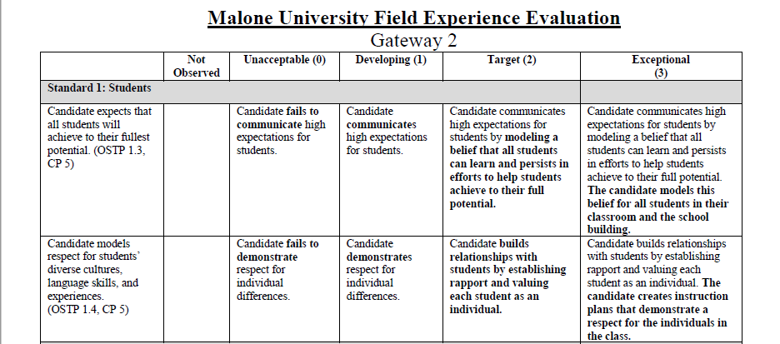
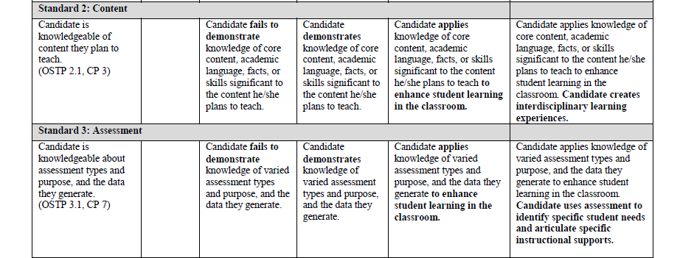
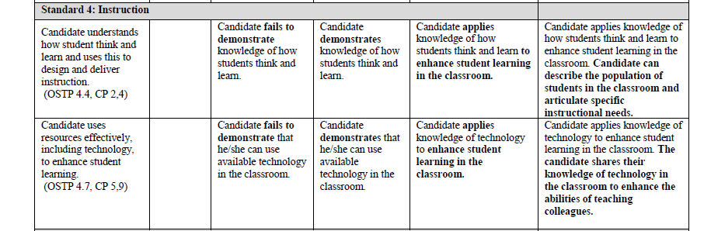
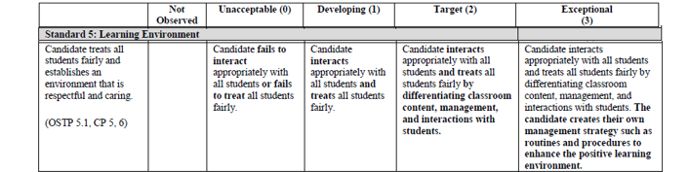
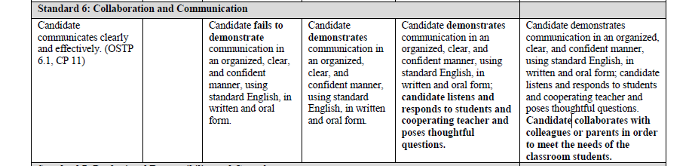
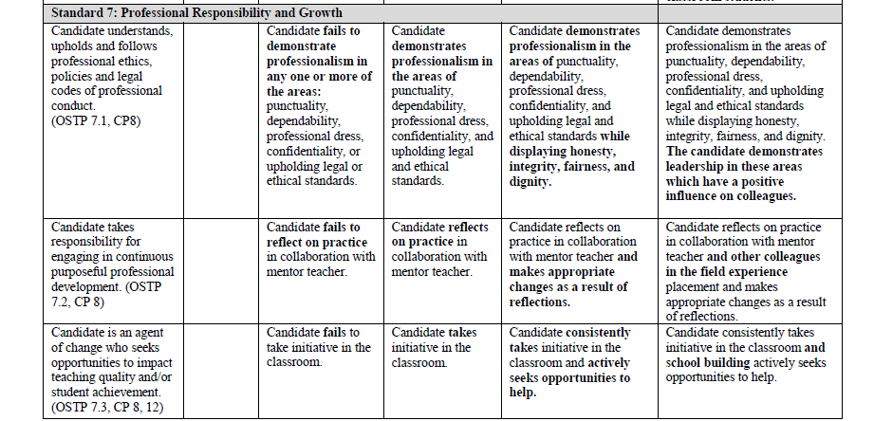

The Field & Clinical Continuum of Responsibilities
The Malone University Continuum of Responsibilities is an overview of suggested activities in which the field experience student (teacher candidate) might engage in during their scheduled time with the mentoring cooperating teacher. This menu of items was created to help you, as a cooperating teacher, engage the field experience teacher candidate in demonstrating the knowledge and skills expected of a teacher. This list is divided by course and Ohio Standards for the Teaching Profession so you may better identify the level of involvement that each Malone student should have based on their level of coursework while ensuring each student has an opportunity to grow professionally in each of the seven Standards of the Teaching Profession. If you observe that the teacher candidate assigned to you is capable of more, please do not hesitate to engage them at the next level(s) of the continuum. We want our teacher candidates to be challenged to grow and be ready for the classroom. This is not an exhaustive list, but a guide. We desire that our future teachers experience as many different aspects of teaching as you can provide for them in your classroom. This list is also not a requirement, but rather a suggestion of experiences that may help guide your partnership with our Malone field students.

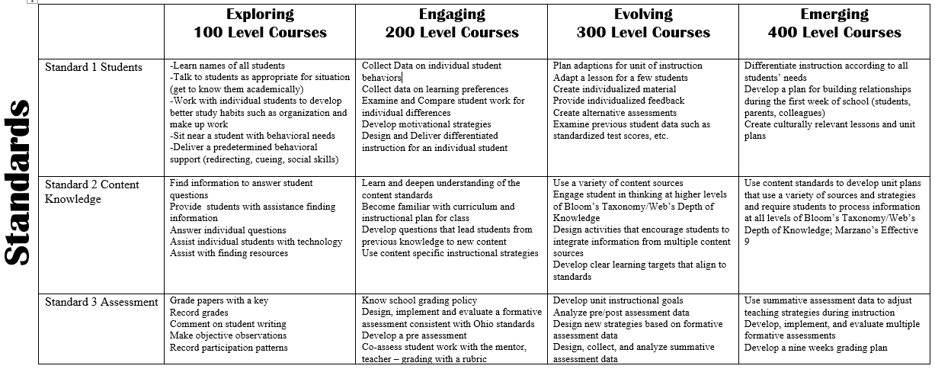
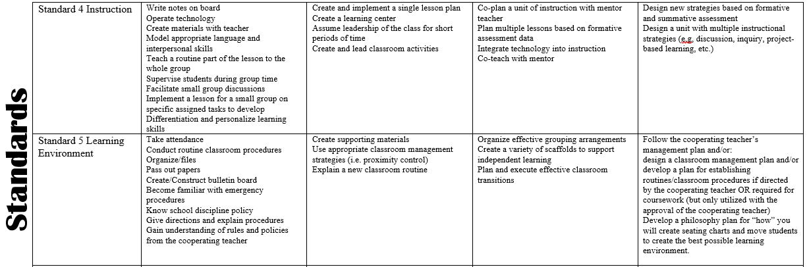

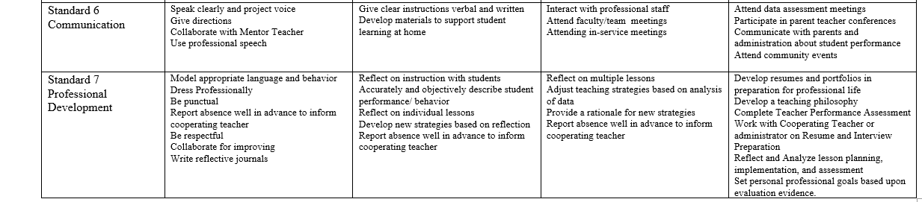

BCI/FBI Form
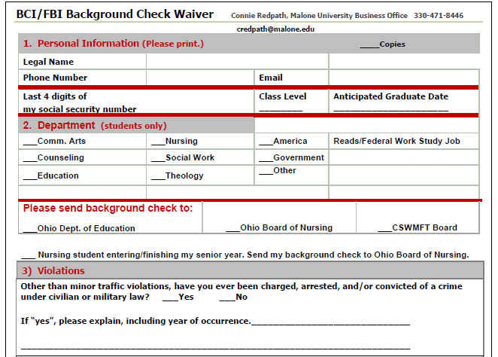
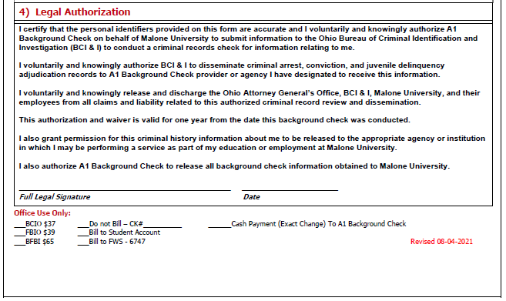

A-1 Background Check Form
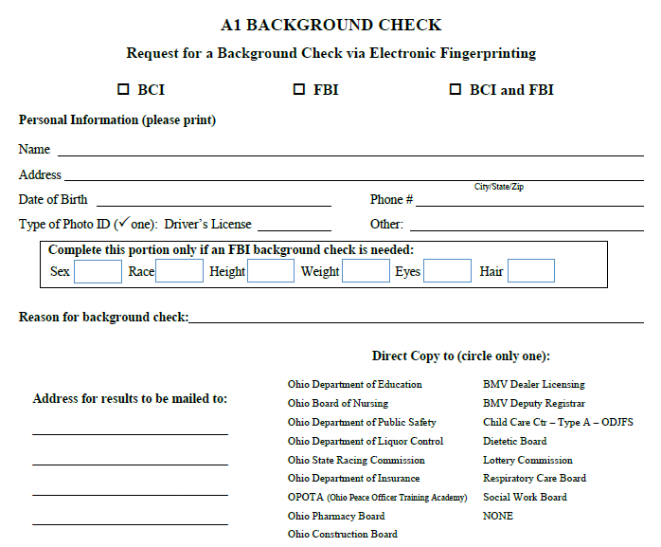
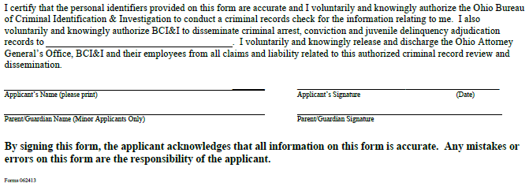

Professionalism in Education
Malone University – Professionalism Module
Indeed.Com (March 11, 2022) 13 Ways To Show Professionalism in Teaching (And Why It Is Important) https://www.indeed.com/career-advice/career-development/professionalism-in-teaching
Teachers master a variety of skills while interacting with students and educational colleagues. Their jobs require a complex blend of instructional abilities and collaborative planning. Showing professional attitudes and actions inside the classroom and out can improve your relationships with students, parents and others in the school community. In this article, we explain the importance of professionalism in teaching, list ways you can prove your dedication to the job and provide tips to help you develop your own standards of excellence.

What is professionalism in teaching?
Professionalism in teaching means a set of implied and explicit standards educators are expected to follow while working as a teacher. Professionalism in the field of education involves interacting with students, colleagues, administrators, parents, and other members of the community in an appropriate and respectful way that encourages a successful learning environment. While teachers share some of the same standards for behavior in the workplace as other professionals such as appropriate dress and communication, specific traits in educators prove an instructor's ability to act with integrity in an educational institution.

Why is professionalism important for teachers?
Acting with integrity and showing courtesy to others is an important way to share and maintain your character and reputation at school. Teachers who show professionalism may have more opportunities to move into leadership positions. Professionalism also helps you gain the trust of parents, students, colleagues, and school administrators. Showing you have the integrity to complete your job responsibilities with excellence gives others confidence in your ability to guide student learning and manage a classroom.
Professionalism is a consistent mode of behavior teachers observe within the practice of education. For classroom instructors, this includes maintaining subject knowledge and instructing students at age-appropriate levels while collaborating with other educators to plan teaching methods. Professionalism in education combines personal growth, collaboration, instruction, and communication, creating a complex set of traits unique to the profession.

How to develop professionalism in teaching
The following ideas can help you increase your professional character as an educator:

1. Learn to value collaboration
Learning to collaborate effectively is an important aspect of a teacher's professional character. Opening your instructional planning to new ideas and input from colleagues often improves students' experiences in your classroom. Working with other educators to meet common goals shows your commitment to a successful learning community. Understanding how to effectively share and accept new ideas, delegate and complete parts of a project and receive critique are all ways teachers can work together to strengthen the educational process.

2. Consider your attire
Choosing the right clothing helps you maintain a professional appearance and can boost your own confidence as an educator. Many schools adopt a business casual dress code for teachers including slacks, tailored shirts and dresses or skirts cut close to the knees. Patterns and colors are appropriate when combined with well-fitting garments. Jeans are also acceptable in some cases provided they are free from rips and holes and fit correctly.

3. Be punctual
Unless events happen that are out of your control, be on time for the start of school, meetings or conferences. Model punctuality to students to encourage their sense of professional values. Setting a schedule for class time can also help you maintain an effective pace for lesson content and encourage students to follow and acknowledge time limits.

4. Maintain a positive attitude
Professionalism involves self-control, including the attitude you show to others in the workplace. Complaining less and taking responsibility for your actions instead of blaming others for mistakes creates a more positive environment for students and colleagues. Striving to be positive in the way you speak to others can also improve your mood and outlook. Smiling is another way to show positivity to others as you communicate.

5. Acknowledge your strengths and weaknesses
Self-knowledge of your own abilities and weaknesses proves a professional awareness of your potential growth areas. Acknowledging your strengths gives you the opportunity to help train and develop others using your strongest skills. This also contributes to a stronger collaborative culture when educators reflect on ways to provide better learning opportunities for students.

6. Seek professional improvement
Listen and contemplate professional development concepts to find ways you can improve your educational practice. Explore new ideas from thought leaders in your discipline and those addressing general concepts in education. Although school administration may provide training and resources, seeking out content knowledge on your own sets a standard for personal growth that contributes to a professional attitude. Some ideas for professional growth resources include:
- Books on pedagogy
- Podcasts about education
- Professional teaching magazines or journals
- Online learning modules
- Educator blogs
- Websites for educational products and resources

7. Give your best effort
Complete work to the best of your abilities using resources to supplement your own skills and expertise. Turn in lesson plans and other professional documents as free from errors as you can make them. Set expectations for completing work such as grading within a certain amount of time. Hard work is an important component of professionalism and fulfilling a set of job responsibilities that meet or exceed the expectations of administrators and community stakeholders is a pivotal part of demonstrating professional character as an educator.

8. Go beyond your job duties
Be willing to help with things outside your classroom to improve your learning community. You can show professionalism when you take time to mentor students and develop genuine care for the well-being of everyone in your classroom, including those who cause disruptions. Showing that you are willing to cross-train and taking the initiative to learn about different disciplines within education can also develop your professional character.

9. Provide clear communication
Responding in a timely way to any communication from peers, students, parents or administration is one way to communicate professionally. It's also important to choose your words carefully to convey your message in a respectful tone with a clear purpose for your audience. Another aspect of professional communication is speaking out when you have a need. This includes asking for help or clarification instead of waiting for someone else to ask you first. Pick the right time and mode of communication to share your ideas to communicate in the most professional manner.

10. Separate your personal and professional life
Professionalism begins with acknowledging the difference between how to behave at work versus how to act during your personal time. Professional educators teach without letting their personal lives affect the quality of their instruction and preparation in the classroom. While acting natural and showing personality in your mannerisms and way of speaking can help you connect with students and colleagues, it's important to balance this with neutral and unbiased language and actions when interacting with others in an educational environment.

11. Prepare and plan
Another key trait that shows professionalism is how an educator prepares for instruction. This includes mastering the instructional content you present to students, planning the most effective resources, activities and assessments to teach course material and understanding the main concepts related to a particular area of knowledge. Teachers who show the most professionalism prepare to instruct students before they enter the classroom by planning the scope and sequence of course content.

12. Adapt to new circumstances
Teachers can exhibit professionalism when they learn to overcome challenges and show their ability to change. Administrators and leading professionals often share the latest teaching methods and philosophies, guiding educators to adopt new ways of instruction. Professional educators adapt to changes encouraged or required by school authorities while assessing what traditional methods still apply in their classroom teaching. An intentional shift in teaching practices supported by research and peer review can show that you are intent on serving your learning community instead of your own comfort or interests.

13. Reflect on your process
Teachers can benefit from strategic reflection and analysis of their instructional process. Using student data to determine the effectiveness of a lesson is one way to gauge the success of a specific unit of instruction. Thinking through the segments of a particular lesson plan, including the direct instruction, activities and assessments and writing down what improvements you'd make in the future can result in stronger teaching methods. Stopping to consider how you can improve is an indication of professional dedication to your craft.
Professional development tips for educators
Consider the following ideas as you plan your continuing education courses and professional growth activities:
- Learn in small chunks. Reading a chapter at a time in educational theory books or listening to a brief podcast about a particular topic can help you digest information easier. Choose one new instructional idea to try over the course of a week or month in your classroom instead of a group of new concepts all at once.
- Learn with your team. Attending training sessions or conferences with your department colleagues can foster a more enjoyable learning experience. You can discuss, plan and test out new ideas with your teammates then reflect together to improve the instructional process for your students.
- Learn what you love. When choosing from continuing education options, consider what motivates you and gets you excited. Learning more about these topics can make it easier to apply new techniques in your classroom.

Learn from local experts. Thought leaders from your district or county may offer training in their areas of expertise. Many of these experts have worked in local classrooms and can provide relevant and helpful ideas for your career.

